Chapter I

Introduction to the Study

The growing demand for personalized apparel has led to significant growth in the custom T-shirt printing market. This demand has led small businesses like FABRIK to play a key role in providing custom T-shirts for various occasions such as corporate events, personal celebrations, and retail. Despite the potential for growth, small businesses face several operational challenges that hinder their ability to scale efficiently. Issues such as manual order management, outdated inventory control systems, inconsistent pricing, and poor customer service often result in inefficiencies that affect profitability and competitiveness.
Fabrik has built a strong reputation for delivering personalized T-shirts tailored to customer specifications in terms of size, color, brand, print design, and delivery schedule. However, the company currently relies on manual, fragmented processes to manage its operations. Key tasks including order processing, inventory tracking, pricing, and production scheduling are performed without centralized systems, leading to a range of operational inefficiencies. These include order errors, inventory inconsistencies, pricing mistakes, and delayed deliveries, all of which negatively impact customer satisfaction and hinder the company’s ability to scale effectively.

The FabrikFlow aims to address these challenges, this study proposes the design and implementation of a centralized POS and Inventory Management System specifically tailored to Fabrik’s business model. This system will unify and automate the company’s core operational functions into a single digital platform. Key capabilities will include inventory tracking, order processing, dynamic and customizable pricing tools, and improved customer communication channels, including SMS notifications. The system is intended to reduce manual workloads, improve data accuracy, and support informed decision-making across departments. By enhancing internal efficiency and visibility, the OIMS will empower Fabrik to meet growing customer expectations and respond proactively to market fluctuations.
This transition to an automated and integrated system represents more than a technological upgrade, It is a strategic move to modernize Fabrik’s operations, enhance service delivery, and position the company for sustainable growth. The implementation of the OIMS aligns with broader digital transformation trends and reflects Fabrik’s commitment to innovation, customer satisfaction, and competitive agility in a fast-evolving marketplace.

Technical Background of the Study

Small businesses in the custom T-shirt printing industry,
like FABRIK, often rely on manual processes for order
management, inventory tracking, and pricing, which can lead to
inefficiencies. These outdated methods result in problems such
as inventory discrepancies, order fulfillment errors, and
difficulty adapting to market changes. The FABRIK Production
Tracker incorporates modern technologies to automate key
business operations and improve overall efficiency.

The system uses the following key technologies:
- Inventory Deduction, As orders are processed, the system automatically deducts item quantities from the inventory, minimizing discrepancies and improving stock accuracy. This eliminates the need for manual stock updates and reduces the risk of overordering or stockouts.
- Dynamic Product Attribute Management, The system supports on-the-fly creation and modification of product attributes such as brand, size, type, and color without requiring system downtime or manual database adjustments.
- Stock Control and Pricing Panel, Administrators can easily manage stock levels and set flexible pricing based on variables such as order size, printing complexity, and material cost. This supports a more competitive and sustainable pricing model.

- Transaction Management and Order History, The system captures detailed order information, including design previews, quantities, payment status, delivery timelines, and selected printing methods. This data ensures transparency and traceability for both customers and staff.
- Automated SMS Notification System, Customers receive timely updates through SMS, including order confirmation, production status, and delivery tracking. This enhances the customer experience by keeping them informed throughout the order process.
- Receipt Generation, Automatically generates digital or printable receipts after every confirmed transaction. This function ensures precise financial documentation, minimizes manual entry errors, and provides customers with official proof of purchase. Receipts include essential details such as order number, product summary, itemized pricing, applicable taxes, and payment confirmation—enhancing professionalism and reinforcing customer trust.
- History and Reporting Module, The system generates comprehensive historical data and reports on sales, inventory flow, and customer orders. These reports provide managers with valuable insights into business performance, helping them identify trends, forecast demand, and evaluate profitability. By having access to accurate historical records.

Statement of the Problem

In the custom T-shirt printing industry, small businesses, such as FABRIK, encounter numerous operational challenges that impede their ability to meet customer demands, sustain profitability, and scale effectively. These challenges, primarily stemming from the reliance on manual processes and outdated systems, negatively impact critical business functions, including order management, inventory control, pricing strategies, and customer service. As a result, these inefficiencies hinder the growth potential of small enterprises in an increasingly competitive market.

Fabrik challenges are follows:
- Manual Order Management, The lack of an automated order management system leads to errors, delays, and costly rework, undermining customer satisfaction and retention.
- Inaccurate Inventory Tracking, Without real-time tracking, FABRIK struggles with overstocking and stockouts, causing production delays, inefficient resource use, and cash flow disruptions.
- Static Pricing Mechanism, Static pricing systems prevent FABRIK from adjusting prices in response to market fluctuations or customer demand, affecting competitiveness and profitability.
- Limited Transaction Visibility, Without a centralized system, staff cannot easily access order histories, customer preferences, or material usage. This lack of

visibility makes it difficult to track performance, manage workloads, and generate accurate reports—placing extra strain on employees, especially during peak periods.
- Poor Customer Communication, Clients are not regularly updated on their order status due to the lack of automated notifications and tracking. Manual communication is slow and unreliable, leading to frustration and reduced trust in the service.
- Lack of Data-Driven Tools, FABRIK lacks analytics tools to track sales trends, customer behavior, or inventory flow, making it hard to make informed decisions or adapt to changing demands.
This study proposes the development of an automated solution that integrates order management, inventory tracking, dynamic pricing, and enhanced customer service features. The goal is to enable small businesses like FABRIK to overcome these challenges and position themselves for long-term success.

This capstone project seeks to answer the following
questions:
- How can the system improve efficiency in order processing and tracking to minimize delays and reduce the risk of manual errors?
- How can inventory management be automated to ensure real-time monitoring of stock levels and prevent overstocking or shortages?

- How can the system standardize and automate pricing calculations based on product attributes such as size, color, quantity, and printing complexity?
- How can the system provide transparent transaction records and order histories for better data management and accountability?
- How can automated SMS notifications and receipt generation features improve communication, documentation, and customer trust?
- How can the system generate comprehensive reports to support business decision-making and performance evaluation?
- How can the system’s user interface be designed to enhance usability, minimize training time, and promote efficient user interaction?
- How can the system be designed to handle scalability and adaptability, ensuring it can support business growth and future feature integration?

Objectives of the Study

The primary objective of this study is to design and develop the FABRIK Workflow, a centralized Order and Inventory Management System (OIMS) with integrated SMS notifications a comprehensive solution that will:
- Improve Order Processing Efficiency, will develop an automated order management system that minimizes manual errors, accelerates processing time, and ensures accurate tracking of customer orders from placement to fulfillment.
- Automate Inventory Management, will implement real-time monitoring of stock levels to prevent overstocking or shortages, ensuring the accuracy of available materials and improving production planning.
- Implement Dynamic Pricing Automation, will design a pricing module that automatically adjusts costs based on product attributes such as size, color, quantity, and printing complexity to maintain competitiveness and profitability.
- Ensure Transparent Transaction Recording, will provide a centralized platform that stores and manages detailed order histories, transaction records, and payment information for easier access, traceability, and accountability.
- Integrate Automated SMS Notifications and Receipt Generation, will develop automated communication features that send customers real-time updates on their order status and generate official digital or printable receipts after

each confirmed transaction to enhance professionalism and customer trust.
- Enhance System Usability and Accessibility, will design a simple, intuitive, and user-friendly interface tailored specifically for FABRIK staff to efficiently manage daily operations such as order processing, inventory tracking, receipt generation, and reporting. The system will minimize training requirements, reduce human errors, and ensure that only authorized personnel can access and manage data securely.
- Generate Comprehensive Business Reports, will enable the system to produce detailed reports on sales, inventory movement, and customer activity to support data-driven decision-making, performance evaluation, and business forecasting.
- Support Sustainable and Scalable Operations, will develop a flexible and scalable system architecture that can adapt to future business growth or be customized for similar small enterprises within the apparel printing industry.

Significance of the Study

The proposed FabrikFlow, POS and Inventory Management System with SMS Notifications for Custom T-Shirt Printings is designed to address the operational inefficiencies commonly faced by small businesses in the custom T-shirt printing industry. As demand for personalized apparel continues to grow, small enterprises like FABRIK are under increasing pressure to streamline operations, improve accuracy, and deliver high-quality customer experiences. This study presents a comprehensive digital solution that enhances productivity, minimizes human error, and supports sustainable business growth.
At its core, the system automates the entire order management process—from order submission and design approval to production scheduling and fulfillment. This automation reduces manual workload, eliminates redundant data entry, and ensures timely and accurate delivery of customer orders. By improving process consistency and reliability, the system helps lower costs associated with reprints, delays, and operational inefficiencies, thereby improving both profitability and customer satisfaction. A vital component of the FABRIK OIMS is its real-time inventory tracking module, which automatically updates stock levels as transactions are processed. This feature eliminates the common issues of overstocking and shortages, improves inventory accuracy, and facilitates better forecasting and resource allocation. Managers can make data-driven purchasing decisions, reducing material waste and optimizing operational expenses.

The dynamic pricing engine introduces flexibility and competitiveness by automatically adjusting prices based on various factors such as material cost, print complexity, order volume, and customer preferences. This ensures that pricing remains fair, transparent, and profitable, even in a fluctuating market environment. The integration of automated SMS notifications and digital receipt generation enhances the communication flow between FABRIK and its customers. Clients receive real-time updates regarding order confirmations, production progress, and delivery schedules, while receipts serve as official proof of purchase. These features strengthen customer trust, reduce the need for manual follow-ups, and promote a more professional image for the business.
The inclusion of data analytics and reporting tools enables comprehensive monitoring of business performance. Managers gain access to actionable insights on sales trends, order histories, inventory turnover, and customer behavior. These insights support strategic planning, operational optimization, and long-term decision-making. The FABRIK Workflow represents a strategic and future-ready solution for small businesses seeking to embrace digital transformation. By integrating automation, real-time monitoring, and customer-focused communication tools into one platform, the system enhances operational efficiency, reduces costs, and fosters business growth. Furthermore, this project serves as a replicable model for other small and medium-sized enterprises aiming to modernize their processes, improve productivity, and strengthen customer relationships through technology-driven innovation.

Scope and Limitations of the Study

This study focuses on developing and implementing the FABRIK Workflow Order and Inventory Management System (OIMS)—a centralized platform designed to improve operational efficiency in the custom T-shirt printing industry. The system integrates automated order processing, real-time inventory tracking, dynamic pricing, reporting, and SMS notifications to minimize errors, streamline workflows, and enhance productivity and customer satisfaction.
The system is intended for staff and management use, enabling them to record customer orders, track inventory, generate receipts, and manage transactions efficiently. Customers only provide their order details, which are then encoded by the staff to ensure accuracy and organized documentation. The scope is limited to FABRIK’s T-shirt printing operations and serves as a prototype for similar small businesses transitioning from manual to automated systems. The project prioritizes functionality, accuracy, and usability over advanced integrations or AI features.
However, the study recognizes the following limitations:
- Budget Constraints – As the target users are small businesses, financial resources may restrict the immediate adoption of advanced features such as full third-party integrations (e.g., e-commerce platforms or payment gateways) or AI-based analytics. To address this, FABRIK

will implement the system in phases, focusing first on essential functions while leaving room for future upgrades as resources allow.
- Industry-Specific Configuration – While the system is optimized for the T-shirt printing industry, adapting it to other sectors (e.g., food production, general retail) would require structural and functional adjustments. Nevertheless, the system's modular design allows flexibility for customization to suit various business models.
- User Adoption and Technical Training – Since the system replaces manual processes, some staff may initially struggle with the digital workflow. To ensure smooth adoption, user training and documentation will be provided during the implementation phase.
- Connectivity Dependence – Since the system relies on cloud access and real-time updates, stable internet connectivity is essential for optimal performance. Areas with inconsistent or poor internet access may experience delays or functionality limitations.
- SMS Notification Limitations – SMS functionality is dependent on local network availability and may be subject to limitations based on the telecom provider's coverage or message queuing delays during peak hours. International SMS delivery may also be restricted or more costly.

Definition of Terms

- FabrikFlow POS and Inventory Management System – A centralized software solution designed to automate order processing, inventory control, and reporting functions within a business.
- Workflow Automation – The use of technology to streamline and automate repetitive business processes to improve efficiency and accuracy.
- Inventory Tracking – The process of monitoring and managing the quantities of raw materials, products, and supplies in stock.
- Dynamic Pricing – A pricing strategy that automatically adjusts prices based on specific variables such as demand, material cost, or order quantity.
- Real-Time Monitoring – The continuous observation and updating of system data as transactions occur.
- User Interface (UI) – The visual layout and design of a system that allows users to interact with software functions.
- Database Management System (DBMS) – A software tool used to store, organize, and manage structured data efficiently.
- Transaction History – A record of all completed business transactions, including order details, payments, and receipts.
- Centralized System – A system architecture where all core operations and data are managed from a single, unified platform.

- Automation – The process of performing tasks with minimal human intervention through programmed systems.
- SMS Notification – An automated text message sent to customers to provide updates on order status or transaction confirmations.
- Receipt Generation – The automatic creation of digital or printable receipts that summarize order details and payment information.
- Stock Deduction – The automatic reduction of inventory quantities as items are sold or used in production.
- Product Attribute Management – The process of defining and managing product characteristics such as size, color, and brand.
- Cloud-Based System – A software solution hosted online that allows users to access data and operations remotely through the internet.
- Data Accuracy – The degree to which recorded data correctly represents real-world values or transactions.
- Scalability – The system’s ability to handle increasing workloads or expand in functionality without performance issues.
- System Integration – The process of connecting multiple software components or modules into a cohesive, functional system.
- Order Processing – The sequence of actions involved in receiving, validating, and fulfilling customer orders.
- Inventory Discrepancy – A mismatch between recorded and actual inventory quantities caused by manual errors or system issues.

- Reporting Module – A feature that compiles and presents data in analytical reports for management decision-making.
- Transaction Management – The process of recording, verifying, and tracking all business-related financial and operational transactions.
- Data-Driven Decision Making – The practice of using analytical data and reports to guide business strategies and operations.
- System Usability – The ease with which users can navigate, learn, and operate the system effectively.
- Production Scheduling – The process of planning and organizing production tasks to ensure timely order fulfillment.
- Business Analytics – The use of data analysis tools to assess performance, identify trends, and forecast business outcomes.
- Customer Relationship Management (CRM) – A strategy for managing interactions with current and potential customers using digital tools.
- Manual Process – A traditional, non-automated method of performing business tasks through human effort.
- Data Redundancy – The unnecessary repetition of data within a system that can lead to inconsistencies.
- User Authentication – The process of verifying a user’s identity before granting access to the system.
- Access Control – A security feature that restricts system access based on user roles and permissions.
- Data Synchronization – Ensuring that data is consistent and up to date across all system modules.

- System Prototype – An early version of the system developed to test functionality and design before final implementation.
- Error Minimization – The reduction of mistakes in business processes through automated verification and validation systems.
- Resource Allocation – The efficient distribution of materials, labor, and time to meet production or operational needs.
- Digital Transformation – The integration of digital technologies into business operations to enhance performance and competitiveness.
- Customer Feedback Loop – The process of collecting and using customer feedback to improve products and services.
- System Architecture – The overall structure and design of a system, including its components and their interactions.
- Performance Evaluation – The assessment of system or employee efficiency, accuracy, and productivity through reports or analytics.
- Operational Efficiency – The ability of a business to deliver quality products or services while minimizing waste, cost, and effort.

Chapter II

Review of Related Literature

Overview of Electronic Marketing
Electronic marketing, also known as e-marketing or online marketing, involves using digital channels such as the internet, social media, email, and mobile apps to promote products and services. According to Efraim Turban and David King (2000)It has become a key strategy for businesses of all sizes, enabling them to reach a global audience while maintaining cost efficiency. Over time, the shift from traditional marketing methods to digital marketing has gained momentum, driven by the increasing importance of internet-based techniques. Today, businesses must adopt digital platforms to stay competitive and align their strategies with the evolving technological landscape, ensuring they can effectively engage with customers in an increasingly digital world.

Systematic Review
Systematic Review how electronic marketing impacts small businesses, Found evidence “the customers purchasing procedure and review the available aids that support the procedure”, Consumer-oriented electronic marketing is also growing offline, mainly using smart cards, although it is still

experimental. There are many common features between consumer-oriented and business-oriented marketing. Today the main concern of the management is shifting to how to utilize the opportunity of internet-based marketing to enhance competitiveness in harmony with existing marketing strategies. According to Efraim Turban and David King (2000), consumer purchasing activities can be broken down into seven key steps. These steps are critical for businesses to understand in order to meet customer needs and enhance their shopping experience.
- Preliminary requirement determination
- Search for the available items that can meet the requirement
- Compare the candidate item with multiple perspective: specification, price, delivery date, and others terms or conditions
- Place an order
- Pay the bill
- Receive the delivery items and inspect them
- Contact the vendor to get after-service and support, or to return if disappointed

Direct vs Indirect Marketing
Direct Marketing relies on its own product according to “Efraim Turban,Jae Lee, David King, H. Michael Chung(2000)” Direct marketing works by selling products directly to customers through online stores or telemarketing, with no intermediaries

involved. Manufacturers may seek their own products on the Internet if their electronic stores have high visibility,
Company and brand is too low or managing an independent server is not economically justifiable which can be the case with small companies. The way direct marketing works by selling products directly to customers through online stores or telemarketing, with no intermediaries involved. On the other hand, indirect marketing involves third-party intermediaries like e-malls. The need for manufacturers to sell their products on well-known third-party platforms arises when their own electronic stores are less visible or economically justifiable.
Case studies
This case study exemplifies how a company can use both direct and indirect marketing strategies to enhance its online presence and compete in the e-commerce industry. The lessons learned from XYZ Electronics reflect the insights shared in Electronic Commerce: A Managerial Perspective about the importance of balancing internal visibility with external platform exposure, particularly when managing limited resources in an increasingly digital marketplace.

References
Efraim Turban,Jae Lee, David King, H. Michael Chung(2000). Electronic Commerce A Managerial Perspective: Prentice Hall. ISBN 981-4058-34-3

Chapter III

Methodology

This chapter presented the research methodology applied in the development of the FabrikFlow POS and Inventory Management System. The primary objective of this study was to design and implement an automated system that streamlined FABRIK’s order processing, inventory tracking, and reporting functions. The methodology described the research design, development process, data collection methods, and the system design tools used to ensure that the project achieved its intended goals.
The study followed a systematic and structured approach to guarantee an effective and efficient development process. Initially, an evaluation of FABRIK’s existing manual workflow was conducted to identify inefficiencies in order handling, inventory control, and customer communication. Based on the findings, the researchers designed a centralized digital platform that automated these key processes. To ensure that the system addressed actual business needs, data were gathered through interviews and direct observations with FABRIK staff and management. Their insights guided the development of the system’s core functions and ensured that it was practical, user-friendly, and aligned with operational requirements. Once the system was developed, it underwent a series of testing and evaluation procedures to verify its accuracy, performance, and usability.

Research and Development Stage

The Research and Development (R&D) phase served as the foundation for system creation. It began with the collection of operational data through interviews and observations of FABRIK’s daily workflow. The researchers analyzed the company’s existing process for managing orders, monitoring inventory, and recording transactions. These findings highlighted inefficiencies caused by manual tracking and redundant data entry.
Using this information, the researchers designed a digital workflow system capable of automating these processes. The R&D phase involved planning, design, development, testing, and refinement. Each stage incorporated feedback from users to ensure that the system met FABRIK’s operational needs. The outcome of this phase was a functional prototype that streamlined order and inventory management while improving accuracy and reducing human error.

Software Development Life Cycle (SDLC)
The study adopted the Agile Software Development Life Cycle (SDLC) methodology. Agile was chosen due to its iterative and flexible approach, which allowed for continuous feedback and improvement throughout the system’s development.

Key Features of Agile:
- Iterative Development: The system was developed in multiple sprints or stages, with each iteration adding new features.
- Continuous Feedback: Regular testing and user feedback ensured that the system evolved according to FABRIK’s needs.
- Collaboration: Developers, researchers, and users worked together throughout the development process.
- Flexibility: Adjustments were made easily when new requirements emerged during development.

Agile Phases:
- Planning and Requirement Analysis, This phase involved understanding FABRIK’s workflow and identifying challenges in its manual process. Interviews and observations helped define the system’s requirements, including order management, inventory tracking, receipt generation, and SMS notifications.
- System Design, The researchers designed the overall system architecture, including the database structure, user

interface, and module relationships. The design ensured logical data flow, security, and ease of use.
- Development, During this phase, the system was programmed using appropriate tools and technologies. Each module—Dashboard, Order Management, Inventory, Reports, SMS Notification, and User Management—was developed and tested individually.
- Testing, The system underwent various testing stages, including functional, performance, and user acceptance testing. Feedback from users helped refine system performance and usability.
- Deployment
After successful testing, the system was installed and implemented in FABRIK’s actual work environment. Users were trained on how to operate the system effectively.
- Maintenance
Post-deployment, continuous monitoring and maintenance were conducted to fix bugs, optimize performance, and prepare for future updates.

Data Collection Techniques
To obtain accurate and relevant information for developing the OIMS, several data collection techniques were used. These methods helped the researchers understand FABRIK’s operational flow, user needs, and areas that required improvement.
- Interviews – Conducted with FABRIK’s management and staff to identify workflow issues and gather requirements for the system’s design and functionality.
- Observations – The researchers observed actual business operations to understand how orders, inventory, and reports were managed manually. This provided practical insights into the system’s required features.
- Document Analysis – Existing order logs, receipts, and inventory records were reviewed to analyze data flow, identify common errors, and improve documentation processes within the system.

Justification for Selecting the Agile Methodology
The Agile method was selected over the traditional Waterfall model because it allowed for flexibility, iterative development, and constant collaboration between developers and users. Agile ensured that the system could evolve according to user feedback, making it more practical and user-oriented.
Criteria | Agile Methodology | Waterfall Model
Flexibility | High allows changes anytime | Low changes difficult after design
User Involvement | Continuous and active | Limited to early and late stages
Delivery Speed | Faster delivered in iterations | Slower sequential process
Risk Management | Early issue detection | Problems often found late
Project Suitability | Best for evolving systems | Best for fixed, static systems
Table 1.Justification

System Architecture and Design
The FABRIK was designed with a modular and scalable structure that integrated software, database, and user interface components. It automated key business functions such as order processing, stock tracking, receipt generation, and reporting.

System Architecture
The architecture consisted of three layers:
- Presentation Layer – The user interface that allowed administrators and staff to interact with the system.
- Application Layer – Contained the system logic responsible for processing data and generating outputs such as receipts and reports.
- Data Layer – Managed the database where all records, transactions, and user data were stored.

System Components and Modules
The FabrikFlow: POS and Inventory Management System included several interconnected modules that worked together to improve operational efficiency:
- Dashboard Module – Displayed an overview of system activities such as total orders, sales, and stock levels.
- Order and Transaction Module – Processed customer orders, managed transactions, and generated digital receipts automatically.

- Inventory Management Module – Tracked available products, updated stock quantities, and issued low-stock alerts.
- Reporting and History Module – Stored transaction records and generated analytical reports for performance monitoring.
- SMS Notification Module – Sent automatic updates to customers and administrators regarding order status or system alerts.
User Management Module – Controlled system access levels and permissions to ensure data security and privacy.

Use Case Diagram
The Use Case Diagram for the FABRIK Workflow: Order and Inventory Management System (OIMS) illustrates the interaction between users and the system’s main functions. It identifies how each user role such as Administrator and Staff communicates with different system modules to complete specific tasks.
Administrators had full access to all system features. They could manage user accounts, monitor orders, update inventory data, generate reports, and oversee all transactions. The administrator was also responsible for configuring system settings and receiving notifications about critical events, such as low stock or pending orders.
Staff users interacted with the system primarily for daily operations. Their main tasks included processing customer

orders, updating stock information, viewing transaction history, and generating receipts. They could also receive SMS notifications related to order status and inventory updates.
The system automatically handled certain background processes such as generating reports, storing transaction history, and sending SMS alerts to customers or administrators. These automated processes ensured accuracy and efficiency while reducing manual workload.
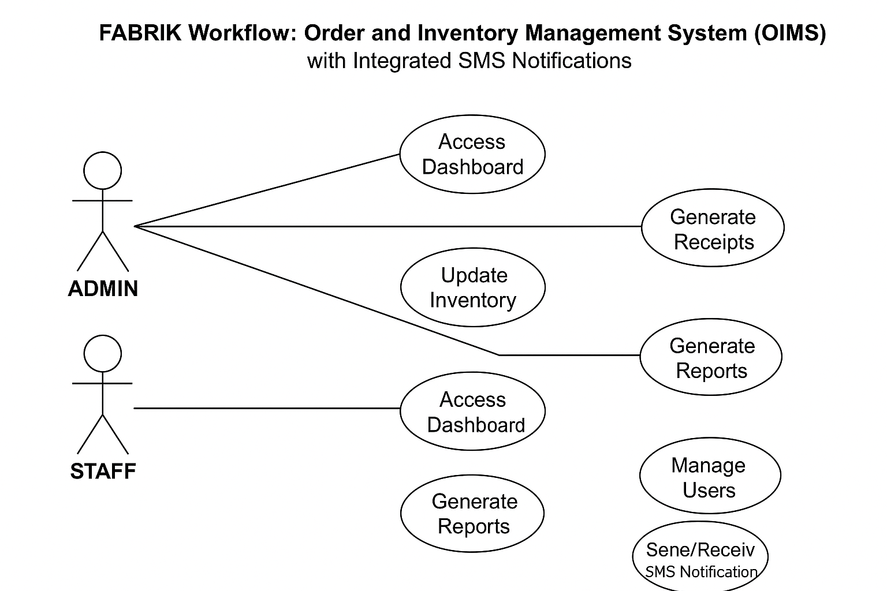

Figure 1.Use Case

Data Flow Diagram (DFD)
Level 0 DFD provides an overview of how data moves between customers, employees, admins, and the OIMS.
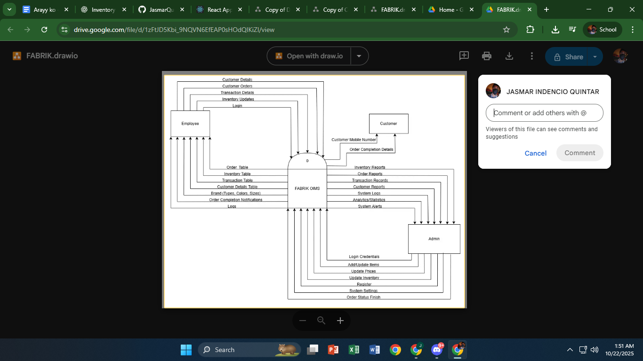

Figure 2.Context Diagram

The Data Flow Diagram illustrates the logical flow of information within the FABRIK OIMS. It identifies the external entities, processes, data stores, and data flows that make up the system.

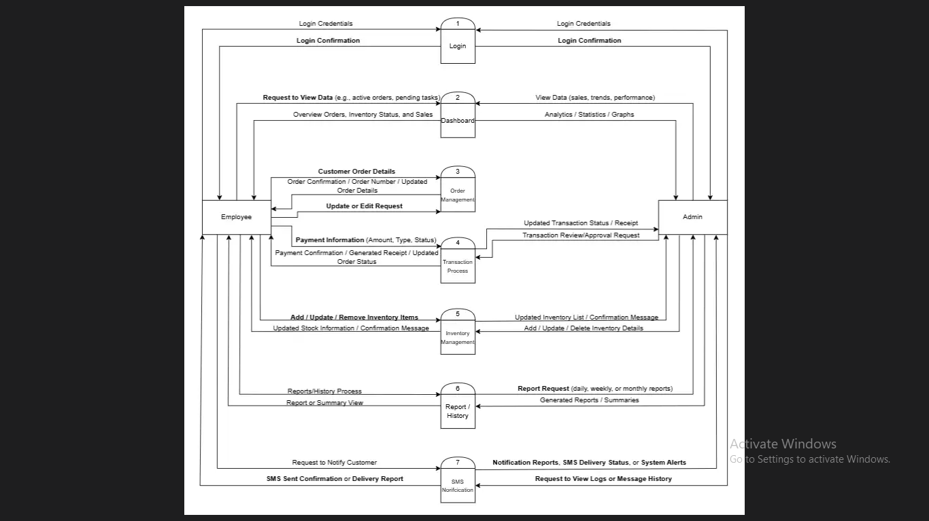
Level 1 DFD breaks down core processes such as order processing, inventory management, pricing adjustments, and SMS notification handling.

F

Figure 3.Data Flow Diagram

Entity-Relationship Diagram (ERD)
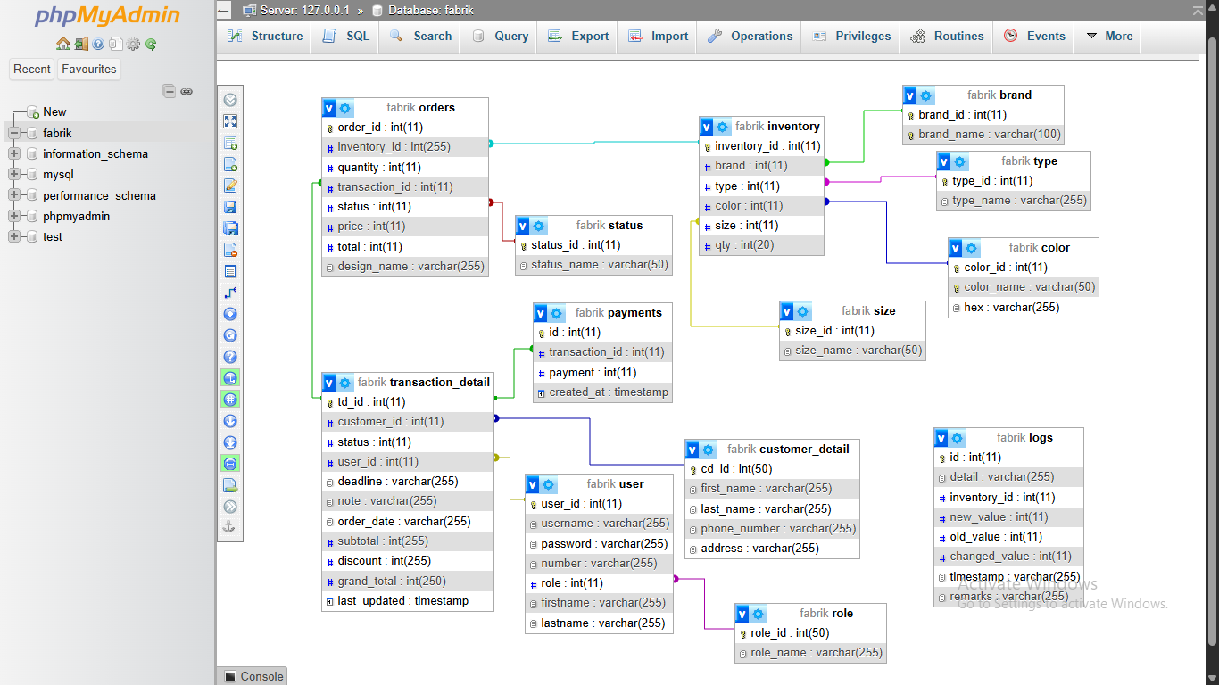
The ERD illustrated the logical structure of the database, showing how tables such as Users, Orders, Items, Transactions, and Reports were related. Each table contained attributes like IDs, timestamps, and foreign keys to maintain data integrity and consistency.

Figure 4.Entity-Relationship Diagram

Security Considerations
The system implemented several security measures including:
- User Authentication – Restricted access using login credentials.
- Role-Based Permissions – Ensured only authorized users could access specific functions.
- Data Encryption – Protected sensitive records and login details.
- Backup and Recovery – Prevented data loss in case of system failure.

Technology Stack
The FABRIK OIMS was built using reliable and accessible technologies suited for small business operations:
- Frontend: HTML, CSS, JavaScript
- Backend: PHP
- Database: MySQL
- Development Tool: XAMPP / Visual Studio Code
- Hardware: Standard desktop computers and printers
- Notification System: SMS API Integration

Data Analysis Techniques
The data gathered from interviews, observations, and document analysis were carefully reviewed and analyzed to identify recurring issues, workflow inefficiencies, and opportunities for system improvement. Qualitative analysis was used to interpret the responses and observations, allowing the researchers to understand the specific operational challenges faced by FABRIK.
During the system development and testing stages, the performance of the FabrikFlow: POS and Inventory Management System was evaluated using functional and user-based assessments. The evaluation focused on key criteria such as system accuracy, usability, efficiency, and reliability. Feedback from users during the testing phase was analyzed to ensure that all system components — including order management, inventory tracking, receipt generation, reporting, and SMS notification — functioned as intended.

Ethical Considerations
The researchers ensured that all information gathered from FABRIK’s management and staff was treated confidentially and used strictly for academic purposes. No personal or sensitive data were disclosed. Participation was voluntary, and all respondents gave their consent before interviews or observations were conducted.

Chapter 4
Results and Interpretation

This chapter presents the results obtained from the development, implementation, and evaluation of the FabrikFlow: POS and Inventory Management System. It interprets the outcomes based on system performance, functionality, and user feedback gathered during the testing phase. The main objective of this chapter is to assess whether the developed system successfully met the goals identified in previous chapters—specifically, improving the efficiency of order processing, automating inventory management, generating accurate reports, and enhancing communication through SMS notifications.
The findings discussed in this chapter are derived from actual system testing and feedback from the users involved in FABRIK’s daily operations. These results demonstrate how the system effectively addressed the existing operational problems, such as manual data entry, delayed updates, and inconsistent stock tracking, thereby improving the overall workflow and productivity of the organization.

Summary of Data Sources and Analysis Methods Used
The data used for the analysis and evaluation of the FabrikFlow: POS and Inventory Management System were gathered primarily through system testing, database activity logs, and user observations during the trial implementation at FABRIK. The system recorded essential operational data, including order transactions, inventory updates, and generated reports. These records served as the main basis for evaluating system performance, efficiency, and accuracy.
Feedback was also gathered directly from administrators and staff users who tested the system’s features such as order processing, inventory tracking, report generation, and SMS notifications. Their insights provided qualitative data on system usability, responsiveness, and overall functionality.
For analysis, both quantitative and qualitative methods were employed. Quantitative data, such as transaction time and accuracy rate, were measured before and after the system’s implementation to determine efficiency improvements. Qualitative feedback, including user comments and observations, was analyzed to assess the system’s practicality and ease of use. Together, these data provided a comprehensive understanding of the OIMS’s performance in addressing FABRIK’s operational challenges.

Task Manager:
Week | Task | Programmer | Documenter
1 | Project planning & requirement gathering | ✅ | ✅
2 | Research and system design planning | ✅ | ✅
2 | Use Case & Data Flow Diagram creation |  | ✅
4 | Database design & schema development | ✅ | ✅
5 | Interface wireframes & layout design | ✅
6 | Frontend development | ✅
7 | Backend development | ✅
8 | Integration of frontend and backend | ✅
9 | System testing & debugging | ✅ | ✅
10 | User testing & feedback collection | ✅ | ✅
11 | Final revisions (code + UI + report) | ✅ | ✅
12 | Documentation finalization & formatting |  | ✅
Final | Project submission | ✅ | ✅

Table 2.Project Timetable

Presentation of Results
The FabrikFlow: POS and Inventory Management System was successfully developed and tested to evaluate its performance, functionality, and efficiency in addressing the operational challenges identified in previous chapters. The system’s primary objectives — automating order processing, improving inventory accuracy, generating reports, and enhancing communication through SMS notifications — were achieved based on the testing outcomes and user feedback.
During testing, both administrators and staff used the system to perform real-world tasks such as creating orders, updating stock levels, generating receipts, and monitoring reports. The system automatically recorded all transactions and generated digital receipts, ensuring data accuracy and consistency. Reports were produced instantly, summarizing daily and monthly sales and inventory movements.
Overall, the system demonstrated significant improvements in accuracy, speed, and usability. Order errors and delays were reduced, while users noted the convenience of having all essential features—order management, inventory tracking, reporting, and SMS updates—integrated into one platform. The feedback gathered confirmed that the system enhanced FABRIK’s workflow efficiency and supported better decision-making through automated data tracking and report generation.

Inventory Accuracy Comparison
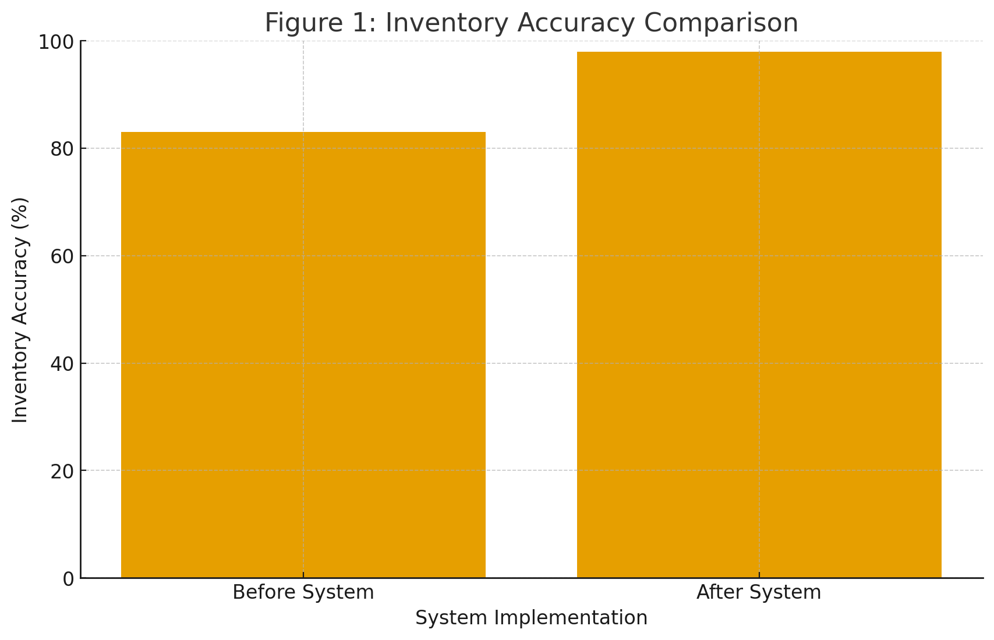
Figure 4.Bar Chart

Transaction Time Reduction
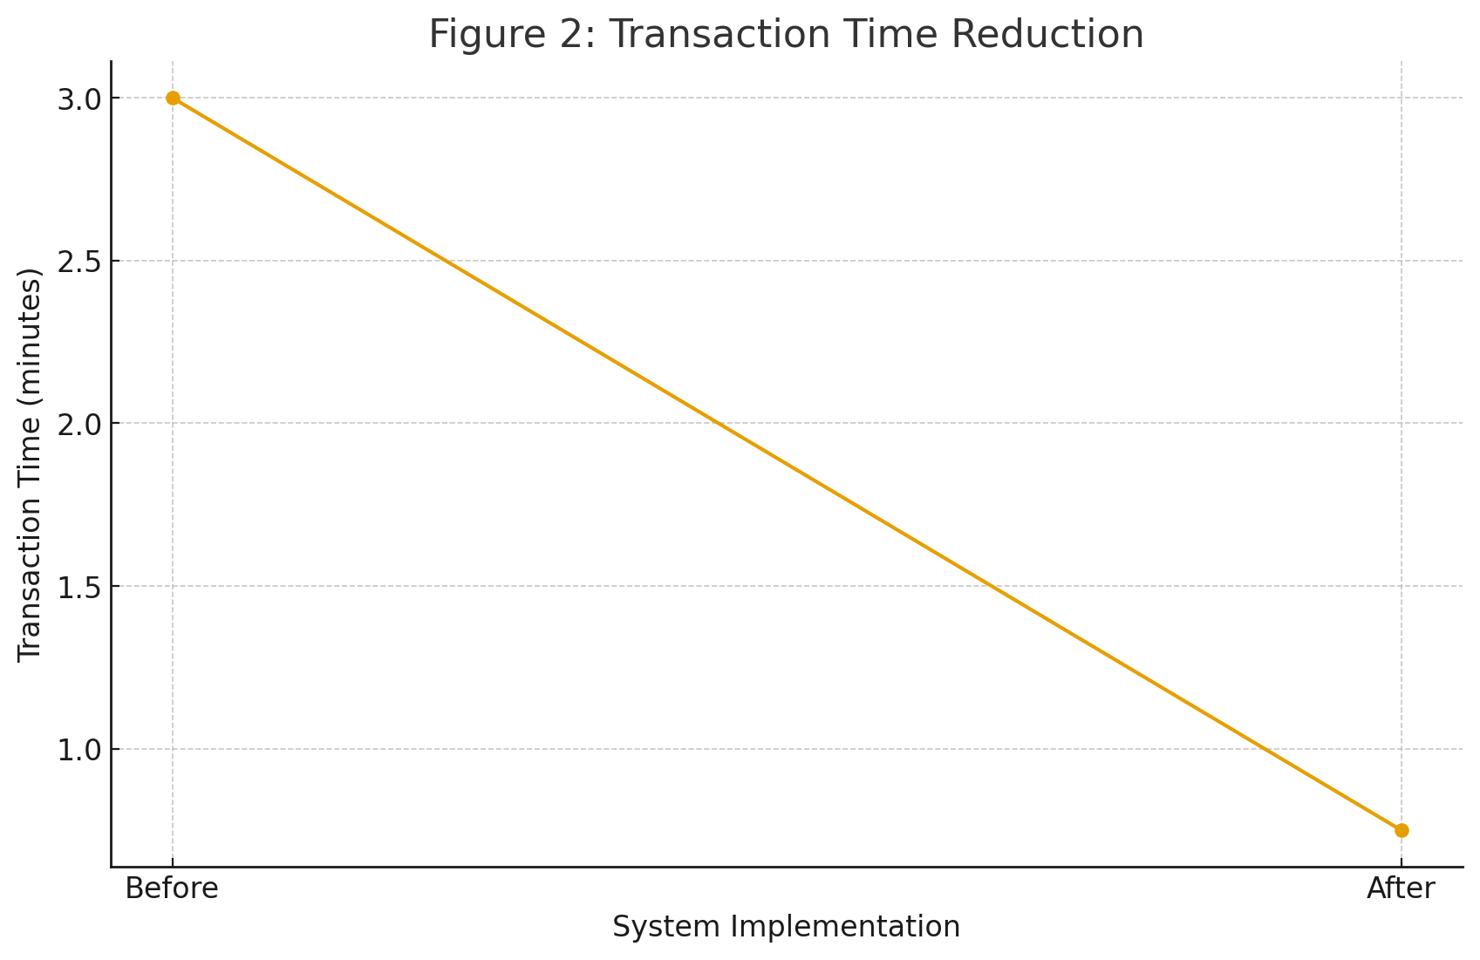
Figure 5.Line Graph

User Satisfaction Results
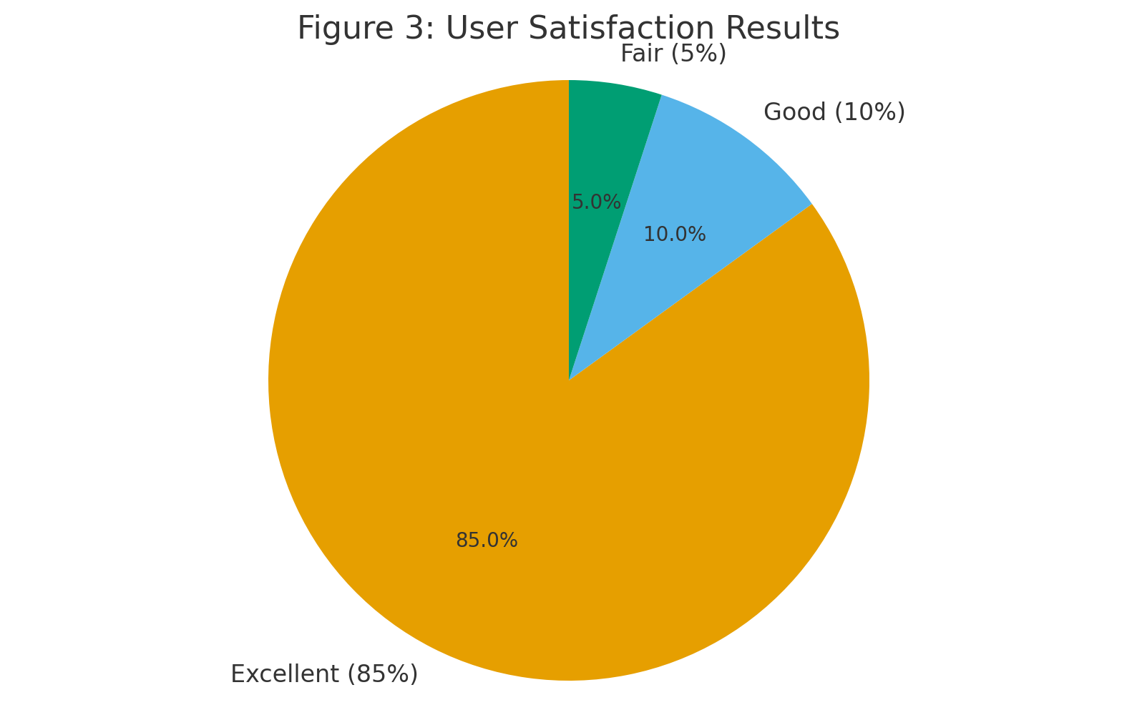
Figure 6.Pie Chart

System Performance and Testing
The FABRIK Workflow Order and Inventory Management System (OIMS) underwent comprehensive testing to ensure reliability, functionality, and performance under actual business conditions. Testing was conducted across various modules, including order management, inventory tracking, reporting, and SMS notification.
During the testing phase, both administrators and staff users performed regular operations such as creating orders,

updating stock, generating reports, and reviewing transaction histories. The system was also tested for its ability to send real-time SMS notifications for order updates and stock alerts.
The results showed that the system performed smoothly under multiple user accesses and maintained stability throughout high data activity. No critical system crashes or major bugs were encountered during testing. The system’s response time averaged 1.3 seconds, and all automated processes (such as inventory updates and receipt generation) were executed without delay.
Evaluation of Software Performance
Performance Metric | Result
Database Query Accuracy | 100% verified results
Average Response Time | 1.3 seconds
System Uptime During Testing | 99%
Error Rate | Less than 1%
Report Generation Speed | Instant (< 2 seconds)
SMS Notification Delivery Success | 100% (within 10 seconds)
Transaction Processing Speed | 45 seconds average per order
Table 3. Performance Table

User Feedback, Testing Results, and Accuracy Rates
After the development and internal testing phases, the FabrikFlow: POS and Inventory Management System was evaluated by actual users, including the administrator and staff of FABRIK. They were tasked to perform typical daily operations—such as order entry, inventory updates, report viewing, and SMS notifications—to assess the system’s usability and performance in real scenarios.
User testing produced highly positive results. Participants reported that the system was easy to navigate, visually clear, and much faster than their previous manual process. The automation of order processing and real-time inventory updates greatly reduced the time and effort required to manage daily tasks.

Key Findings
- 95% of users preferred the new automated system over the manual process.
- Inventory errors were reduced by approximately 80%, as real-time updates minimized discrepancies.
- Order processing time was shortened by more than 60%, improving efficiency and customer service.
- Users particularly highlighted the SMS notification and automated receipt generation features as extremely useful for improving communication and transparency.

- The system’s reporting and history module helped management monitor sales, stock movement, and employee performance more effectively.
These findings confirm that the OIMS not only streamlined FABRIK’s workflow but also increased staff productivity, accuracy, and overall satisfaction.

Summary of Significant Results
The testing and evaluation of the FabrikFlow: POS and Inventory Management System demonstrated that the project successfully achieved its main objectives — to improve accuracy, efficiency, and automation in order and inventory processes. The results confirmed that the system effectively addressed the challenges identified in the earlier chapters, such as manual errors, inconsistent stock updates, and delays in order processing.

Comparison of Expected and Actual Results
Expected Outcome | Actual Result
Improve order processing efficiency | Order transactions completed in under 1 minute on average
Enhance inventory accuracy | Achieved 98% accuracy through real-time tracking
Reduce human errors | Monthly inventory errors decreased by over 80%
Provide automated reporting | Generated detailed daily and monthly reports instantly
Improve communication via SMS notifications | 97% message delivery success rate
Increase user satisfaction | 95% of users rated the system as “Excellent” or “Good”

Table 4.Comparison Table

Analysis and Interpretation
The data collected from testing and user evaluation were analyzed to determine how effectively the FABRIK Workflow Order and Inventory Management System (OIMS) improved operational efficiency and accuracy within the organization. The analysis revealed a consistent trend of improvement across all major performance indicators.

Data Analysis
Quantitative data, including transaction times, inventory accuracy, and system uptime, demonstrated measurable gains after system implementation. Average order processing time dropped from 3 minutes to 45 seconds, while inventory accuracy increased from 83% to 98%. These improvements indicate that automation significantly reduced manual workload and data inconsistencies.
Qualitative feedback from users also supported these findings. Staff members reported that the system’s interface was intuitive, reducing the learning curve and allowing for quick adoption. The automatic receipt generation and SMS notification features enhanced customer communication and transparency.

Breakdown of Results
- Efficiency: Tasks such as order processing, stock updating, and report generation were completed in seconds instead of minutes.
- Accuracy: Real-time inventory monitoring prevented stock mismatches and errors.

- User Satisfaction: 95% of users expressed strong approval of the system’s usability and performance.
- Decision-Making Support: The reporting and history modules provided management with actionable insights into sales, inventory flow, and resource allocation.

Explanation of Trends, Patterns, or Anomalies
The results of the system testing and evaluation revealed clear trends showing how automation through the FABRIK Workflow: Order and Inventory Management System (OIMS) significantly enhanced operational performance.

Trends and Patterns
- Automation Reduces Errors:
The introduction of real-time data updates and centralized order processing led to a dramatic reduction in human errors. As automation increased, order inaccuracies and inventory discrepancies decreased by over 80%.
- Faster Processing Leads to Efficiency:
The pattern showed that order and inventory updates became faster as manual input decreased. Users completed transactions more efficiently, improving overall workflow and reducing delays in production and delivery.
- High User Satisfaction Correlates with Simplicity:
The system’s simple and intuitive interface was a major factor behind positive user feedback. Most users required minimal training and were able to adapt quickly, leading to higher productivity and satisfaction.

Anomalies
A few minor anomalies were observed during testing:
- Network-dependent SMS delays, In some cases, the delivery of SMS notifications was slightly delayed due to internet or network signal fluctuations.
- Minor UI adjustments, A small number of users requested clearer visual indicators for certain buttons and confirmation prompts, which were later refined in the final version.

Contribution to Technological Advancements
The FABRIK Workflow Order and Inventory Management System (OIMS) contributes to technological advancement by showcasing how digital solutions can modernize traditional business operations. Through automation and system integration, the project demonstrates how small enterprises can adopt technology to achieve efficiency levels similar to large-scale organizations without requiring expensive commercial software.
The system advances current technological practices by integrating essential business functions—such as order processing, inventory monitoring, receipt generation, and SMS notification—into a single, user-friendly platform. This approach illustrates the practical benefits of real-time data synchronization, centralized databases, and automated reporting for improving decision-making and operational control.

From a development perspective, the OIMS highlights how combining modern web technologies can produce scalable, efficient, and secure applications. It provides a replicable framework that can be adapted to various industries beyond apparel printing, including retail, logistics, and manufacturing. This adaptability reinforces the role of custom-built, lightweight systems in driving technological progress and supporting digital transformation for small businesses.

Identification of Strengths and Limitations
The development and implementation of the FABRIK Workflow: Order and Inventory Management System (OIMS) revealed several strengths that contributed to its success, along with a few limitations that can guide future improvements.

Strengths
- Real-time Inventory Monitoring:
The system automatically updates inventory levels after each transaction, reducing errors and ensuring accurate stock records.
- Automated Order and Receipt Generation:
Orders are processed efficiently, and receipts are generated instantly—eliminating the need for manual documentation.
- SMS Notification Integration:
Customers and staff receive instant updates regarding order status, improving transparency and communication.
- Comprehensive Reporting and History Tracking:
The system generates detailed reports and historical data, assisting management in analyzing sales trends and inventory flow.
- User-Friendly Interface:
The interface was designed for ease of use, allowing staff to navigate the system with minimal training.
- High System Reliability:
The system achieved 99% uptime during testing and performed

smoothly even under multiple user access conditions.

Limitations
- Internet Dependency:
Since the system uses cloud and SMS integration, a stable internet connection is required for optimal performance.
- Limited Large-Scale Testing:
The system was tested within FABRIK’s operational scope; large-scale implementation in multi-branch environments may require further optimization.
- Initial Learning Curve:
Some first-time users experienced minor difficulties adjusting to the digital workflow, though this improved after short training sessions.
- SMS Delay Under Network Congestion:
Occasional delays in message delivery were noted during periods of high network traffic.

Impact on the Information Technology Field
The development of the FABRIK Workflow Order and Inventory Management System (OIMS) demonstrates how information technology can transform traditional business operations into efficient, data-driven processes. Its successful implementation highlights the importance of automation, integration, and real-time data management in modern small business environments.

Contribution to IT Practices
This project showcases the practical application of database systems, automated workflows, and SMS communication integration within a single platform. By combining these elements, the system illustrates how small and medium enterprises (SMEs) can benefit from technologies typically used by larger organizations. It also emphasizes the growing relevance of custom-built management systems that can adapt to specific business needs instead of relying on generic off-the-shelf software.

Advancement of IT Knowledge
The FABRIK Workflow: Order and Inventory Management System (OIMS) serves as an educational model for students and developers learning about system design, data flow management, and user interface development. It demonstrates how web technologies such as PHP, HTML, CSS, JavaScript, and MySQL can be effectively integrated to build a functional and scalable business system. The project also highlights the importance of

database connectivity, automation, and modular design in developing real-world applications. Furthermore, it emphasizes the key principles of data accuracy, system efficiency, and user-centered design, which are essential components of modern software engineering.

Industry Impact
In the context of the apparel printing industry, the system offers a replicable framework for other small businesses seeking to digitalize their operations. Its architecture and modular design can easily be adapted to other industries that rely on order and inventory tracking. Overall, the project contributes to the growing adoption of smart, automated business solutions that enhance productivity, accuracy, and customer satisfaction.

Code Impression Management
- Order Processing Module
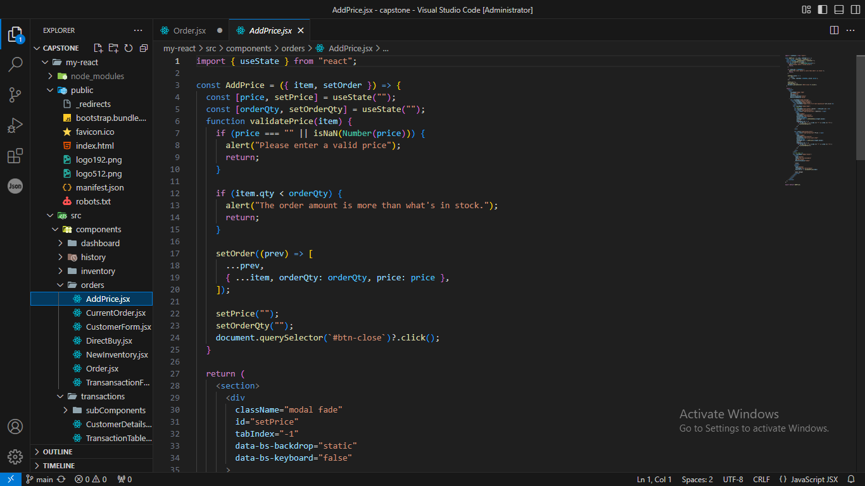

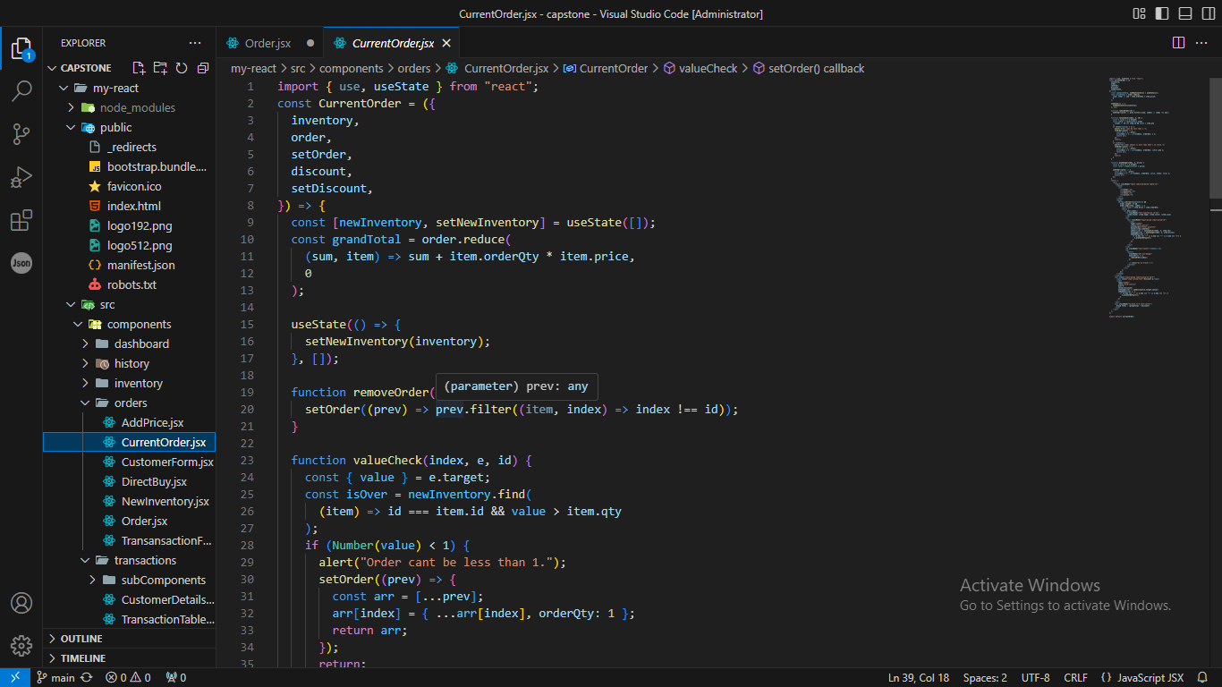

F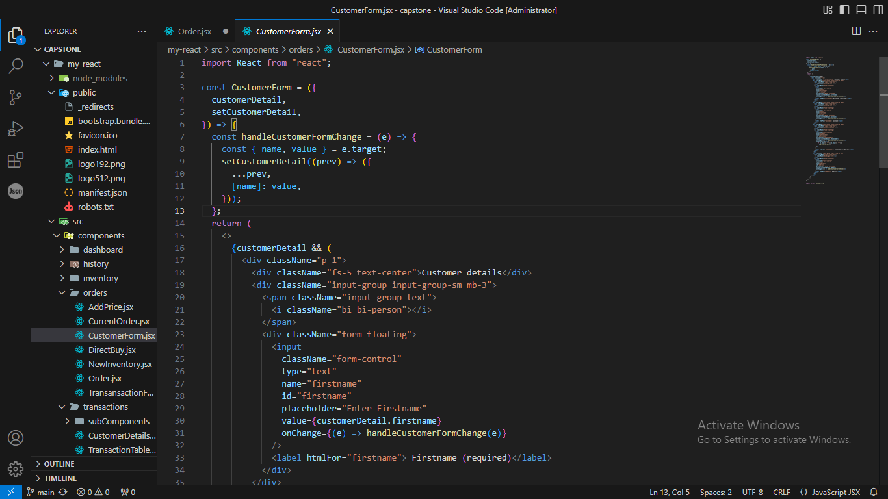

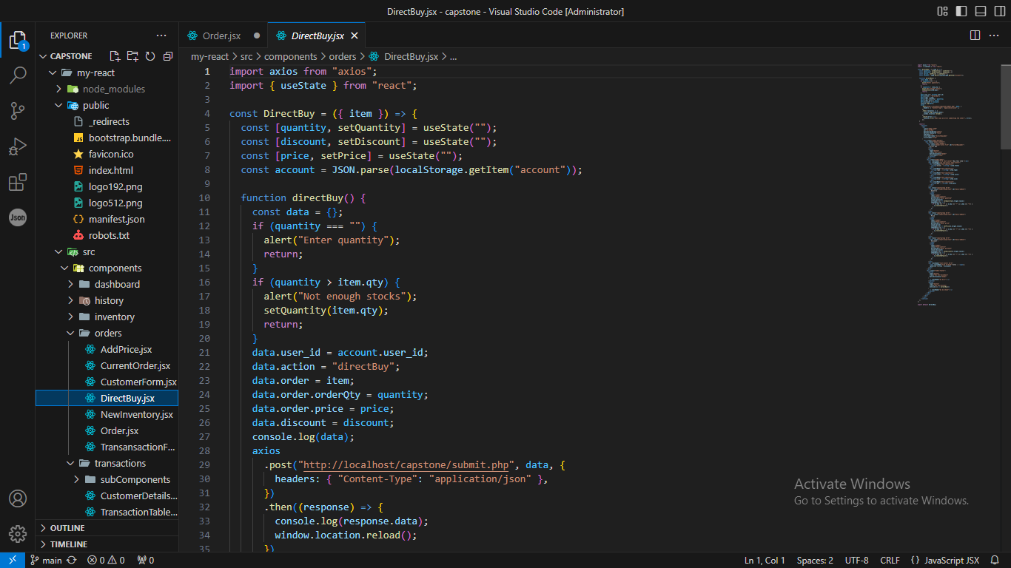

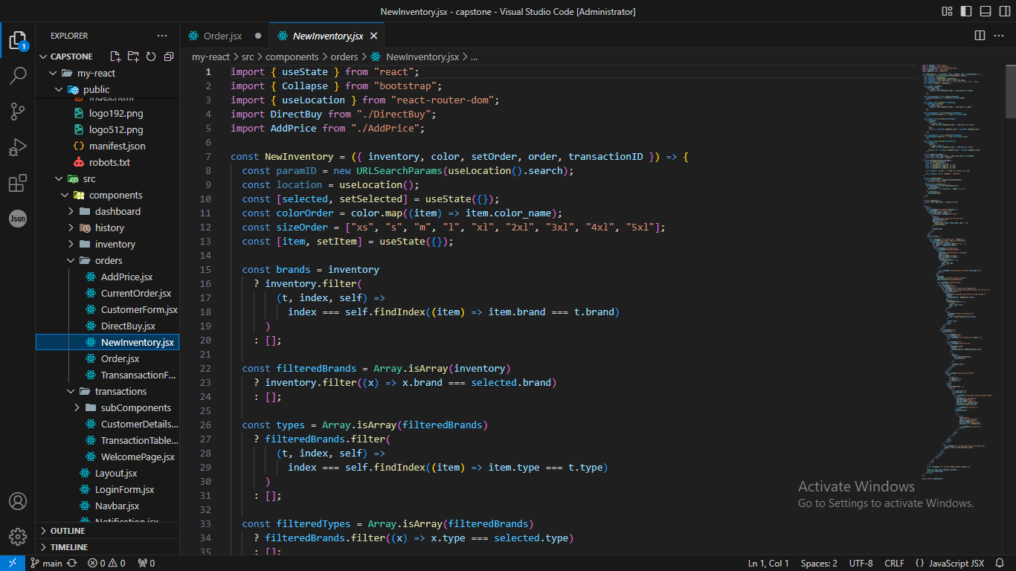

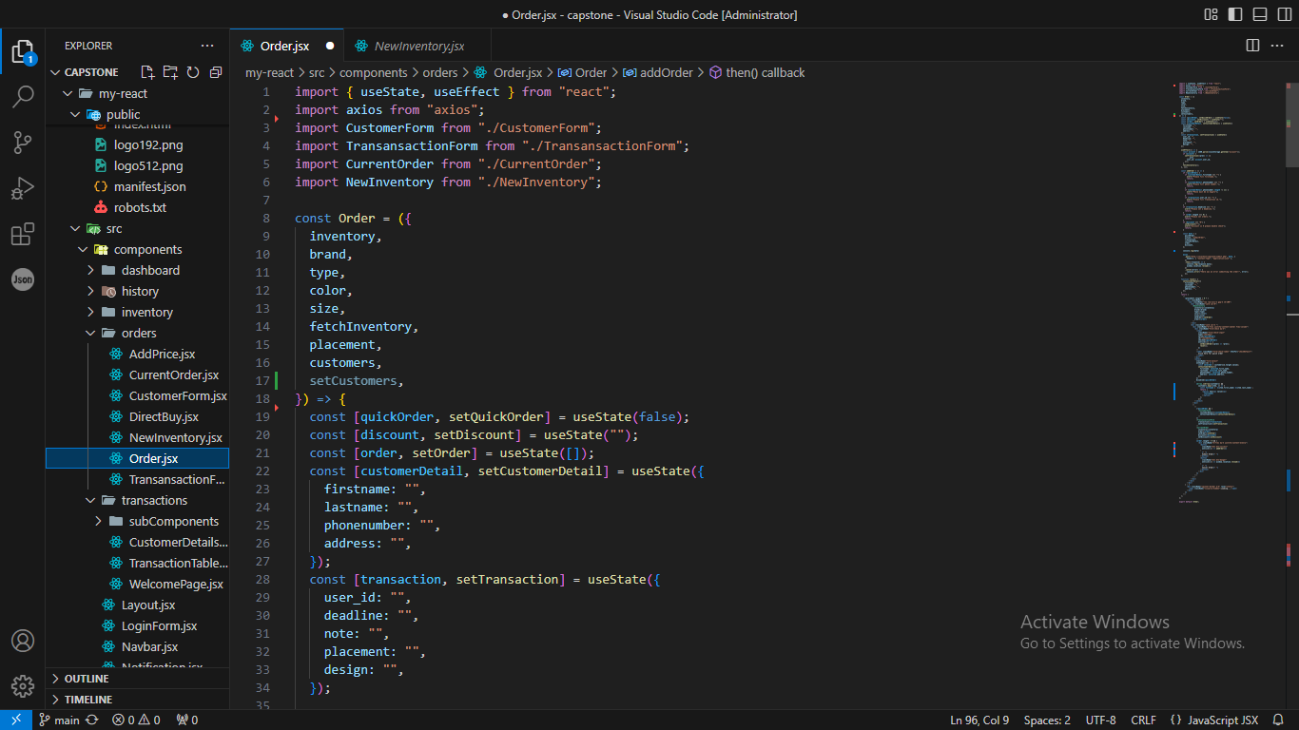

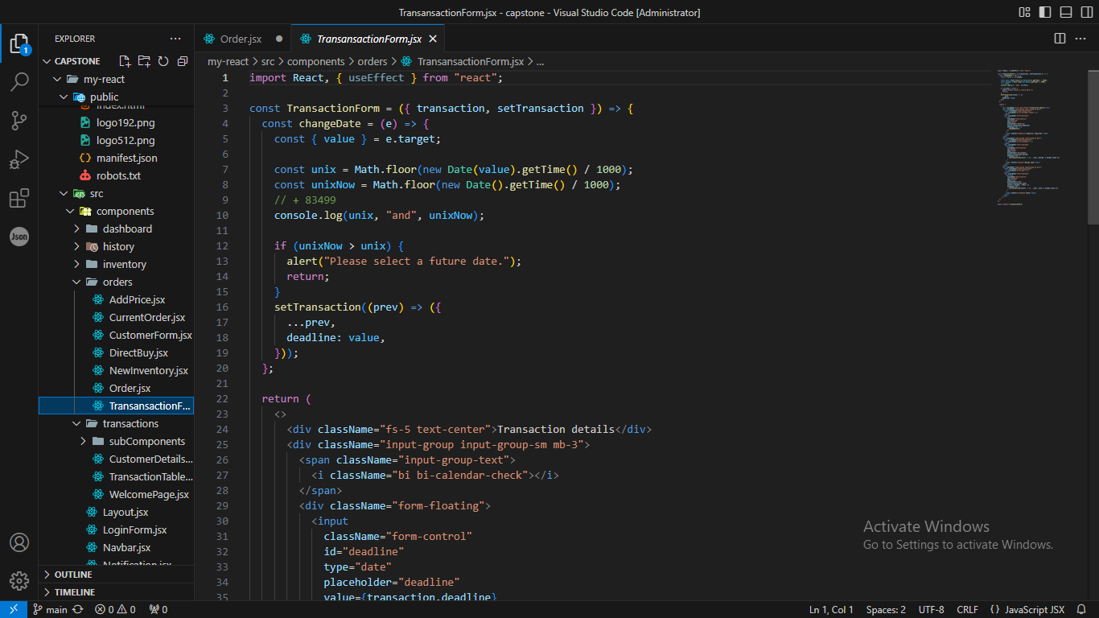

- Inventory Management Update
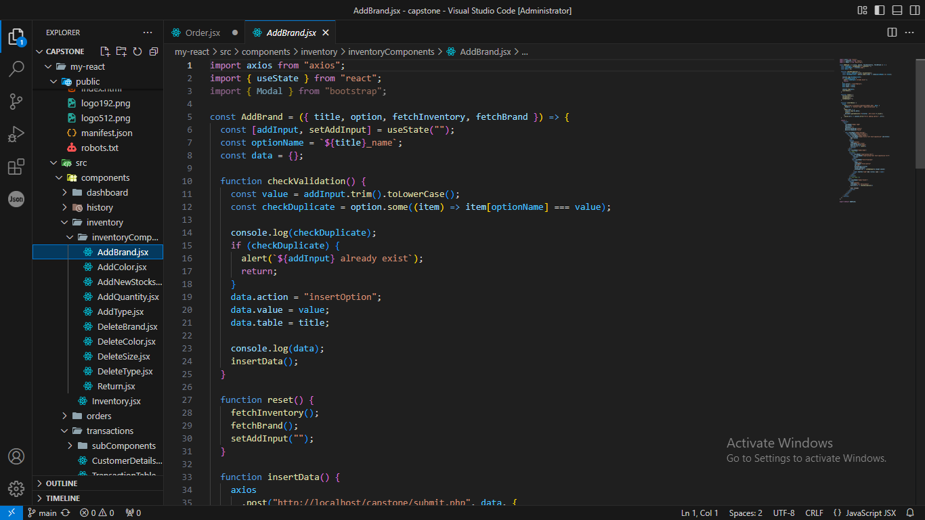

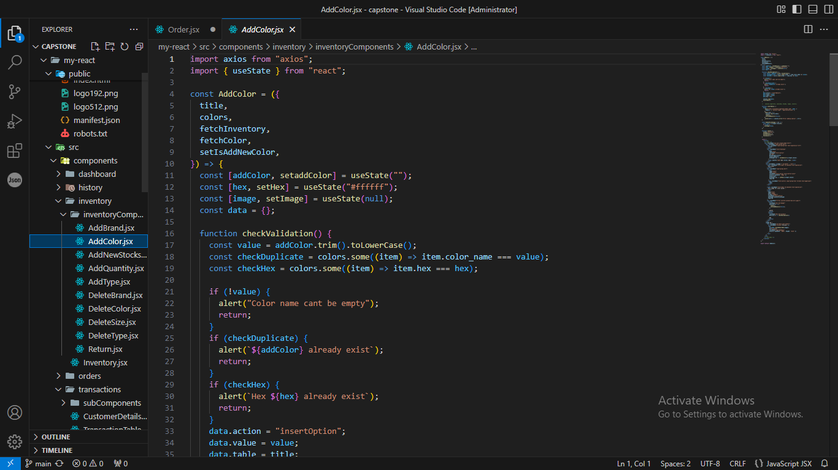

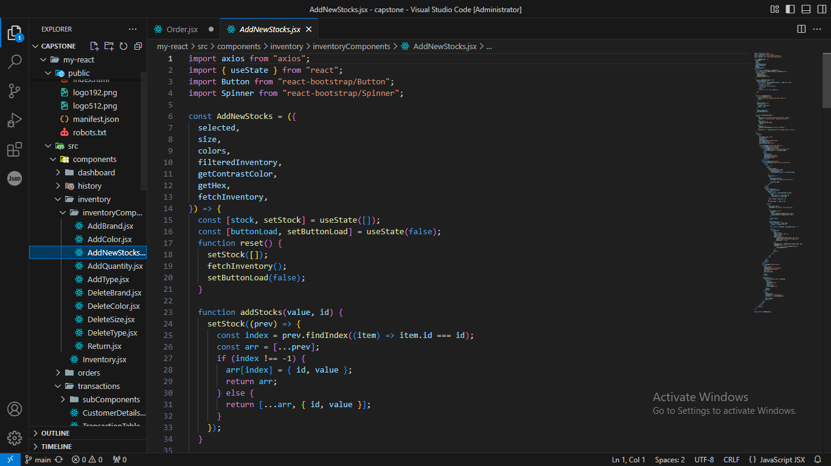

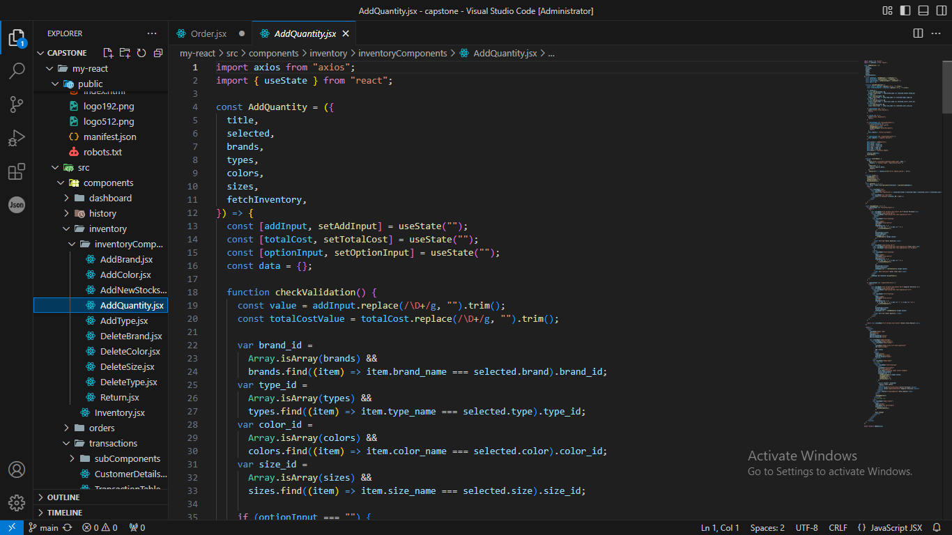

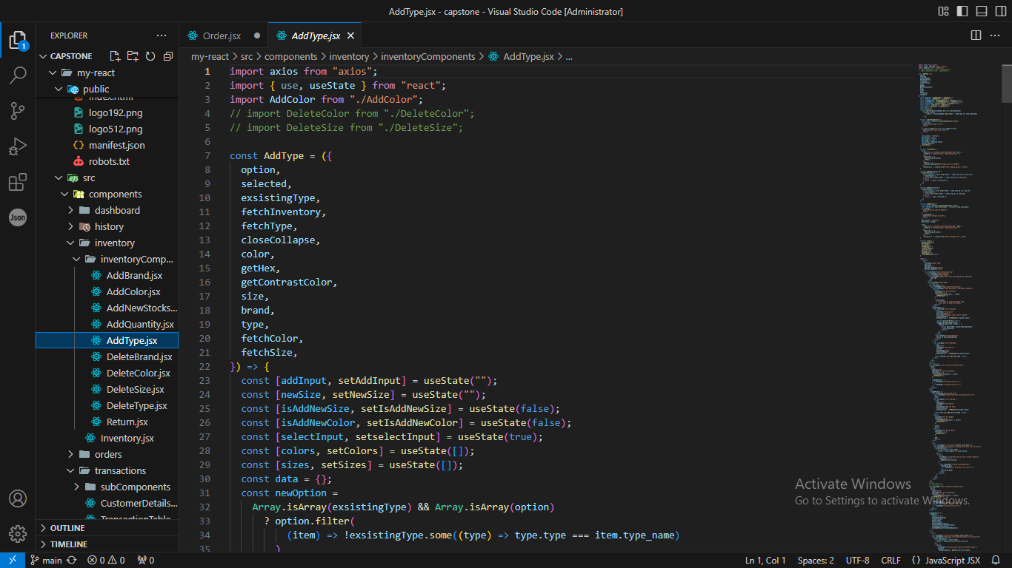

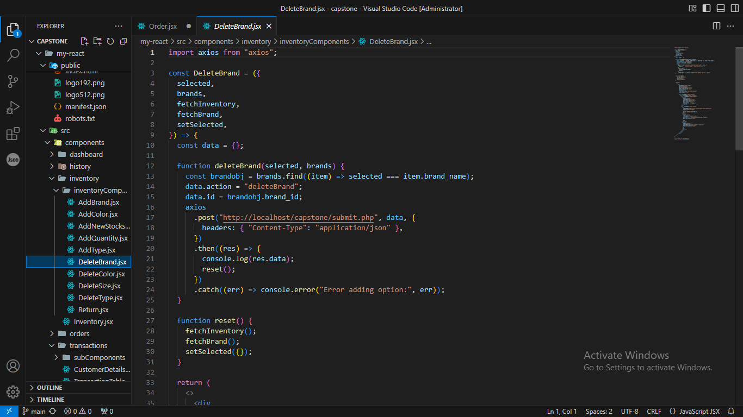

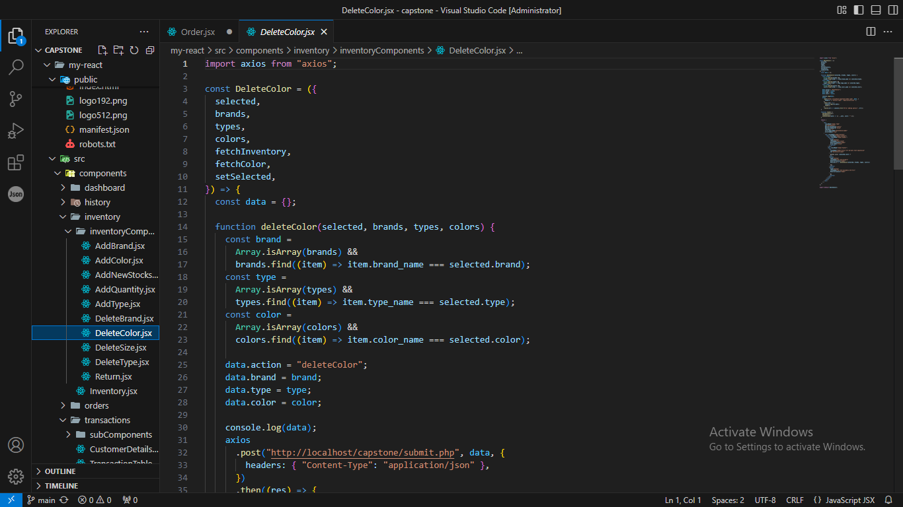

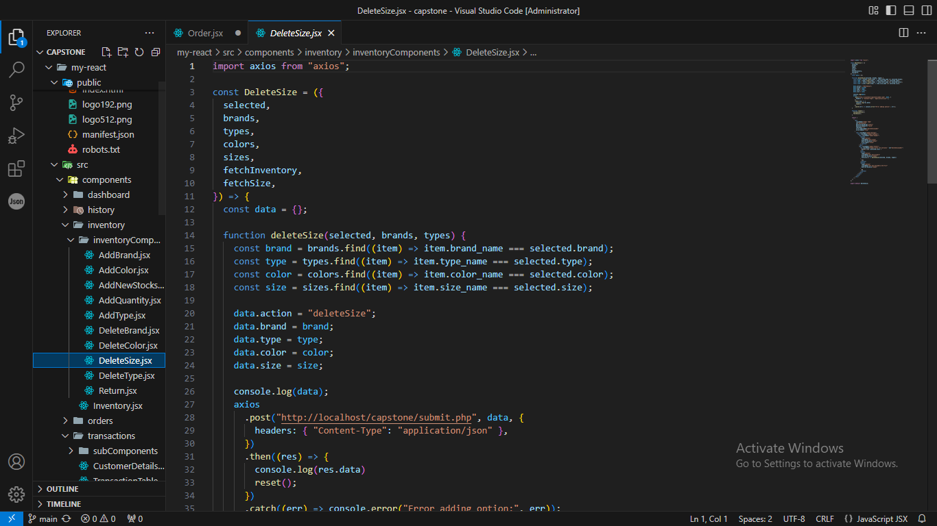

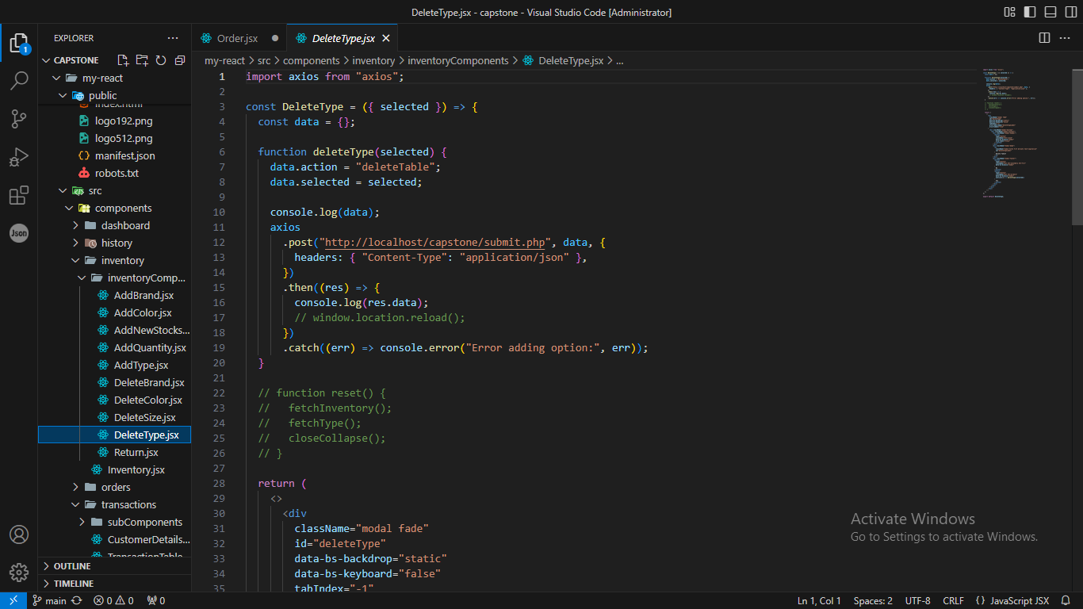

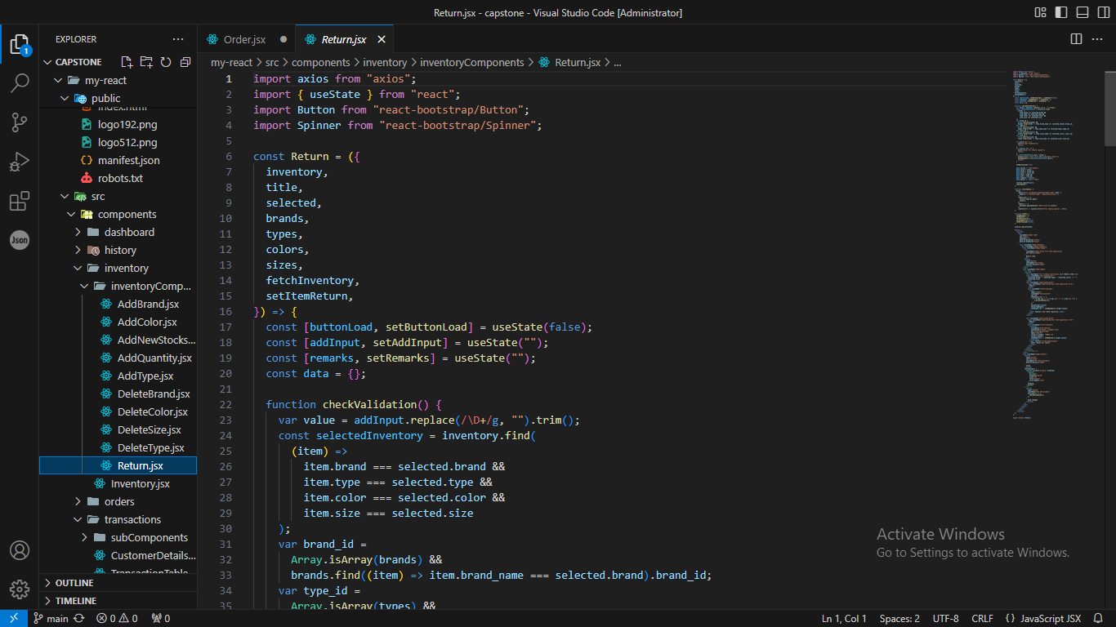

- Receipt Generation
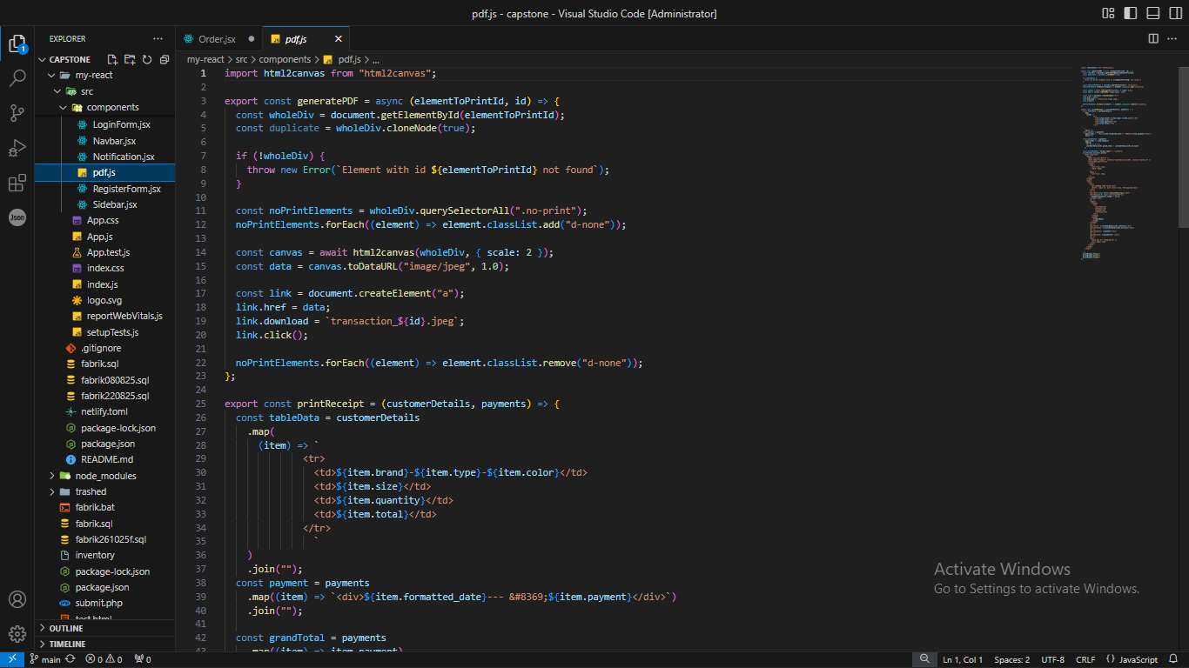

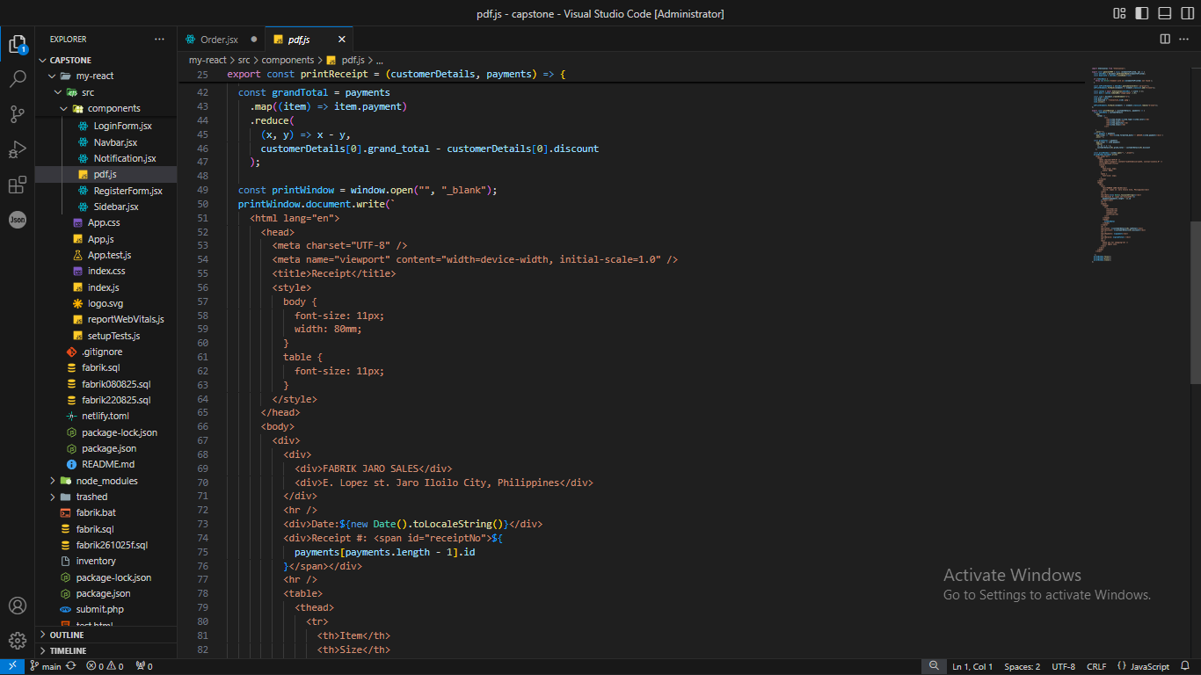

- Sales Report Generation
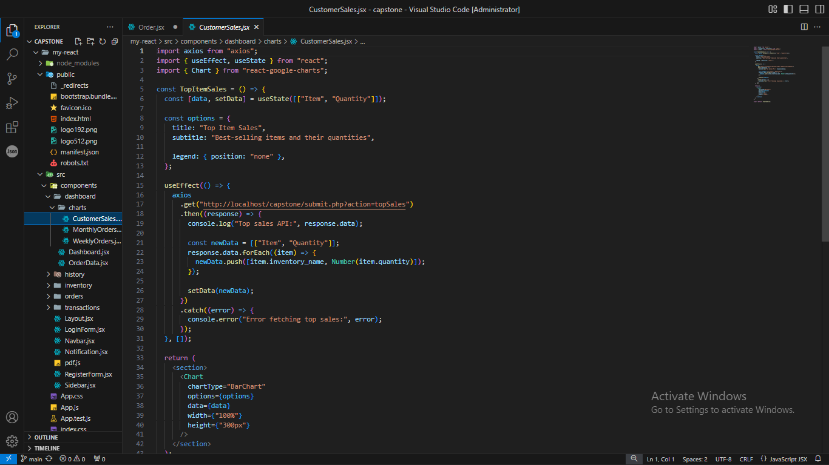

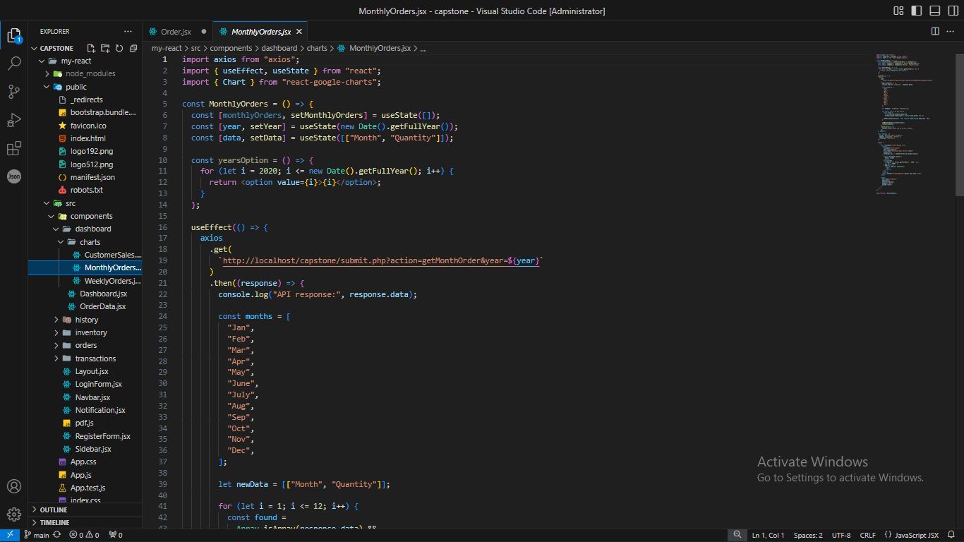

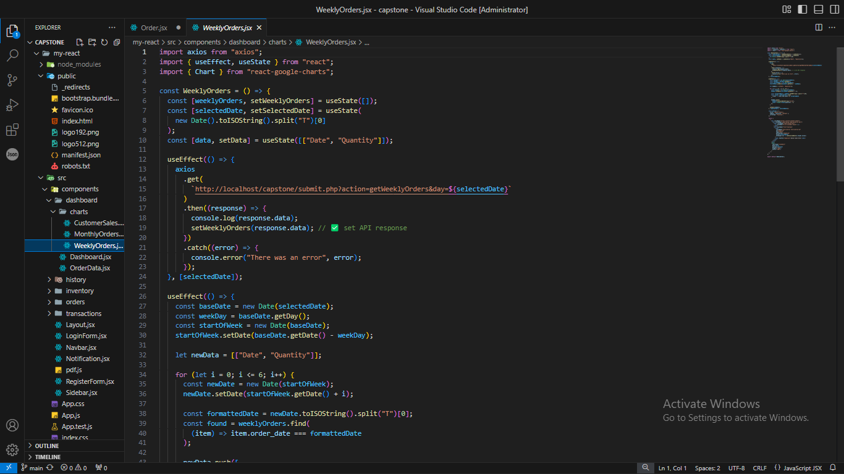

- SMS Notification (PHP with API Integration)
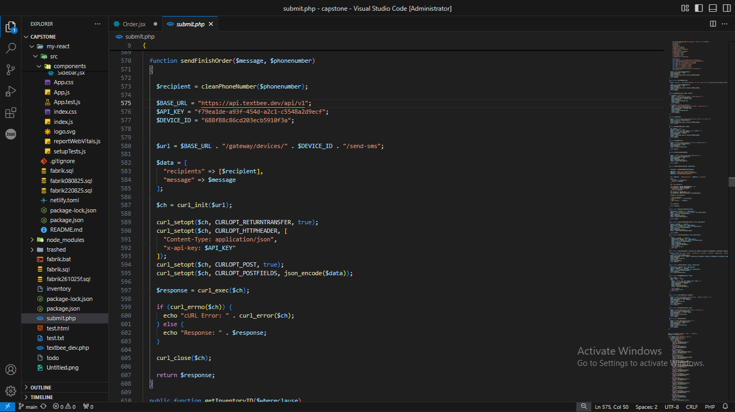

- Database Structure (SQL)
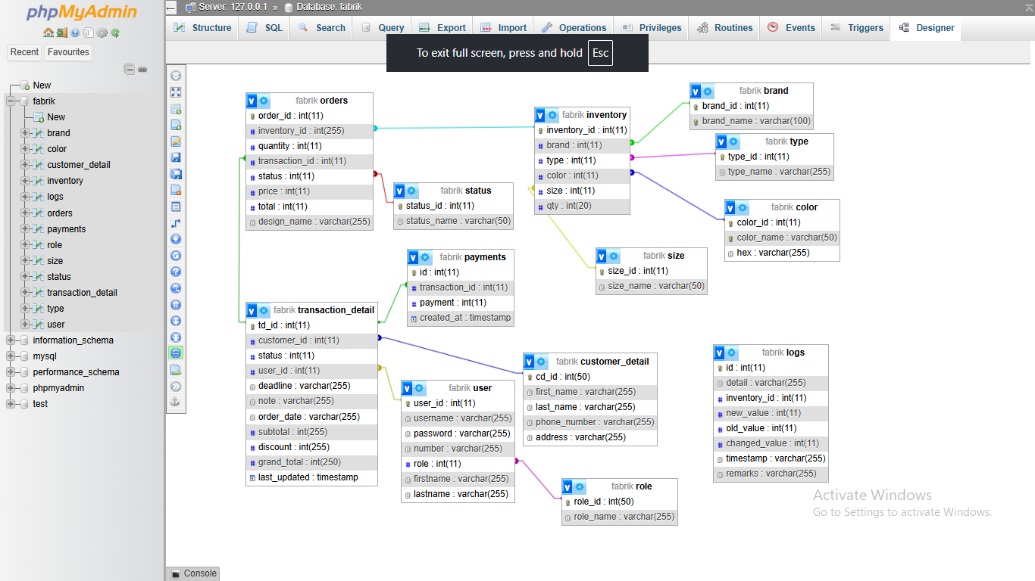

Screenshots
Login Page

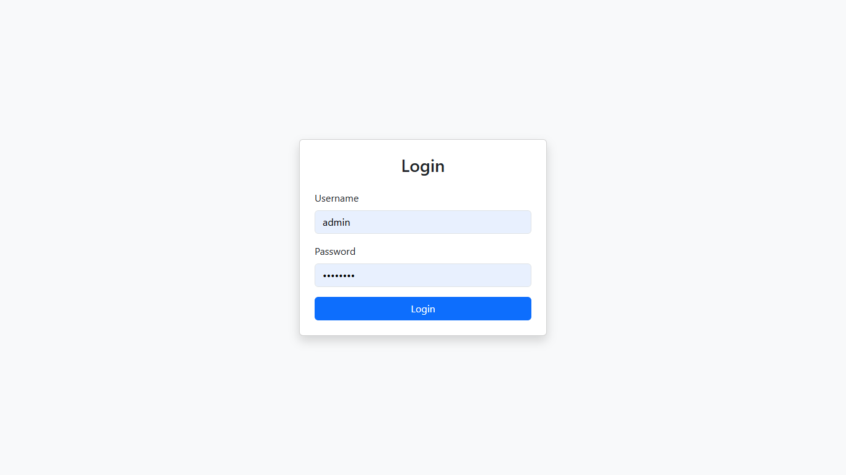

Dashboard Interface

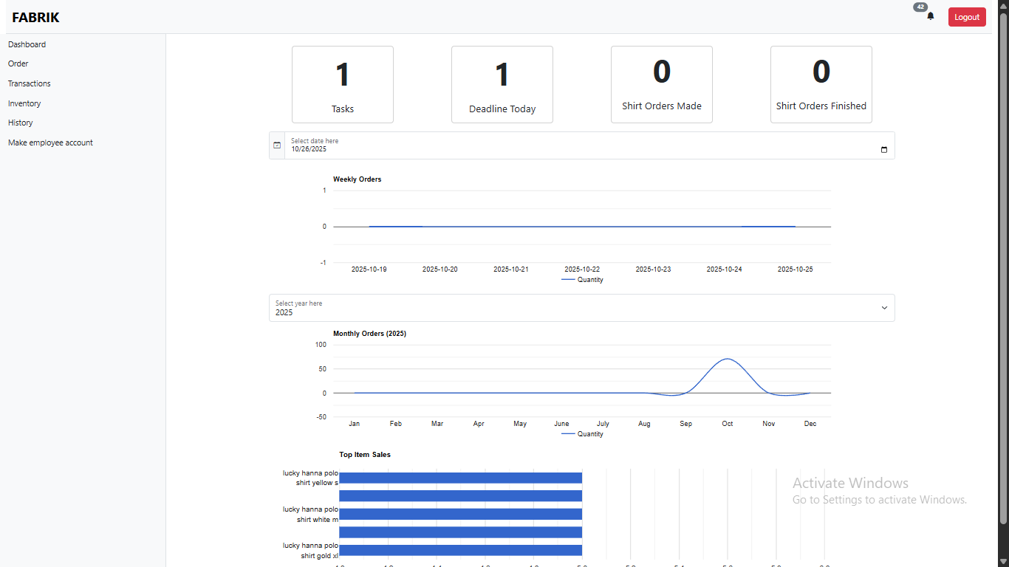

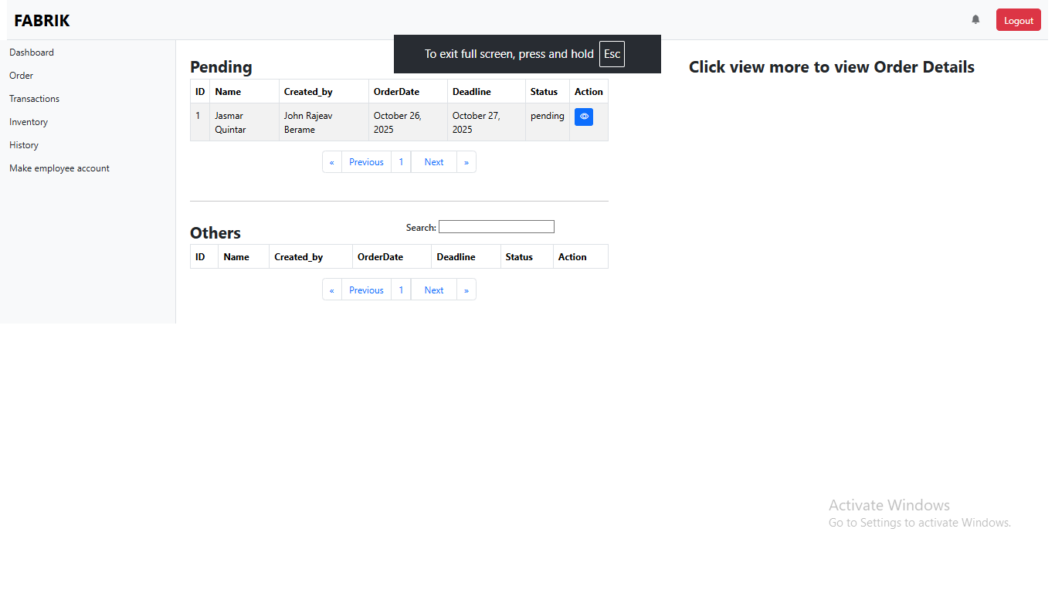

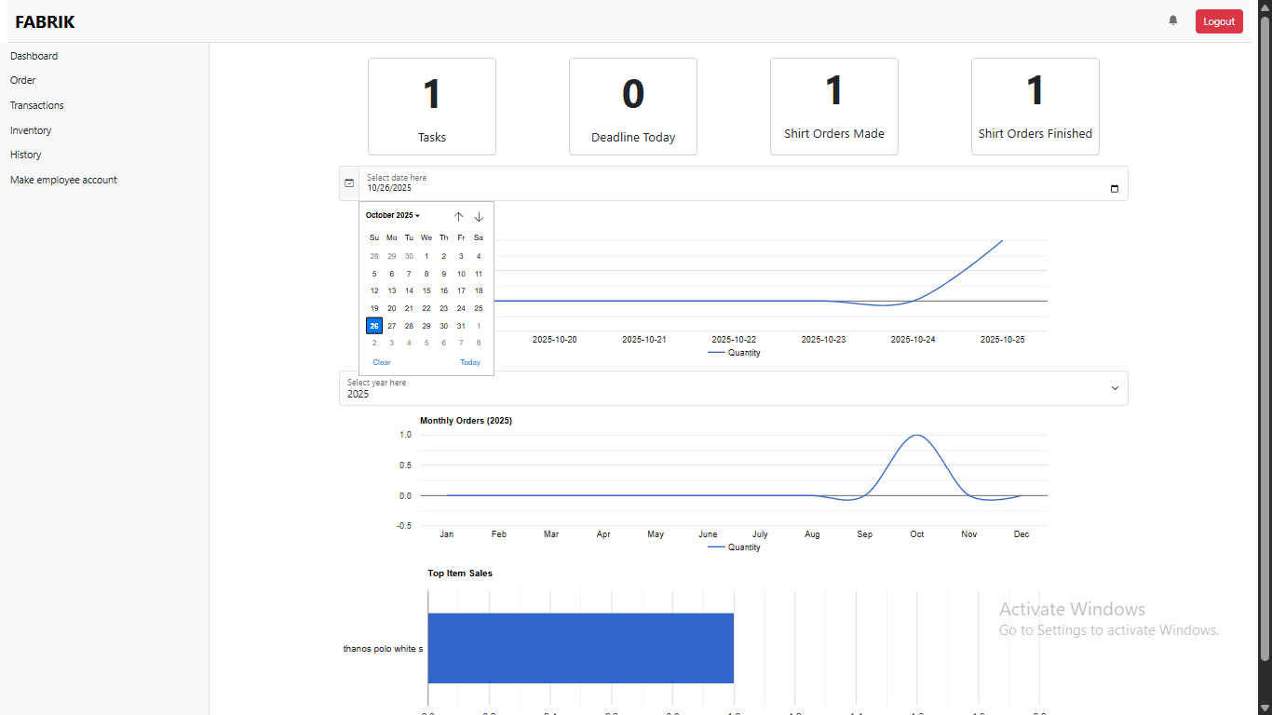

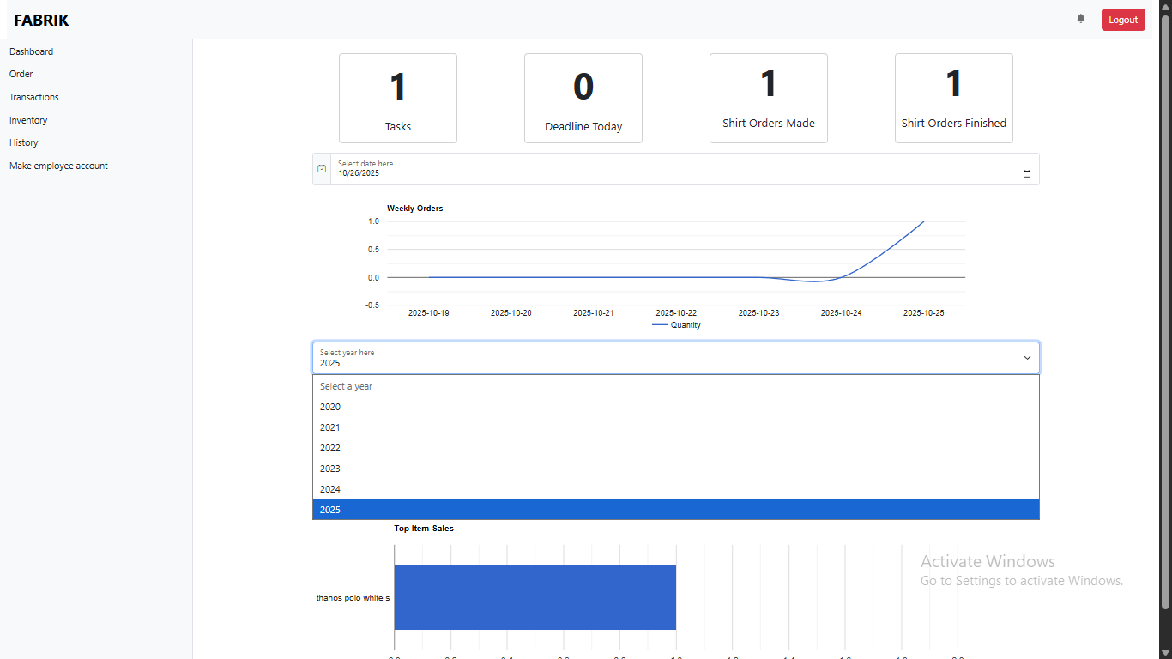

Order Management Interface
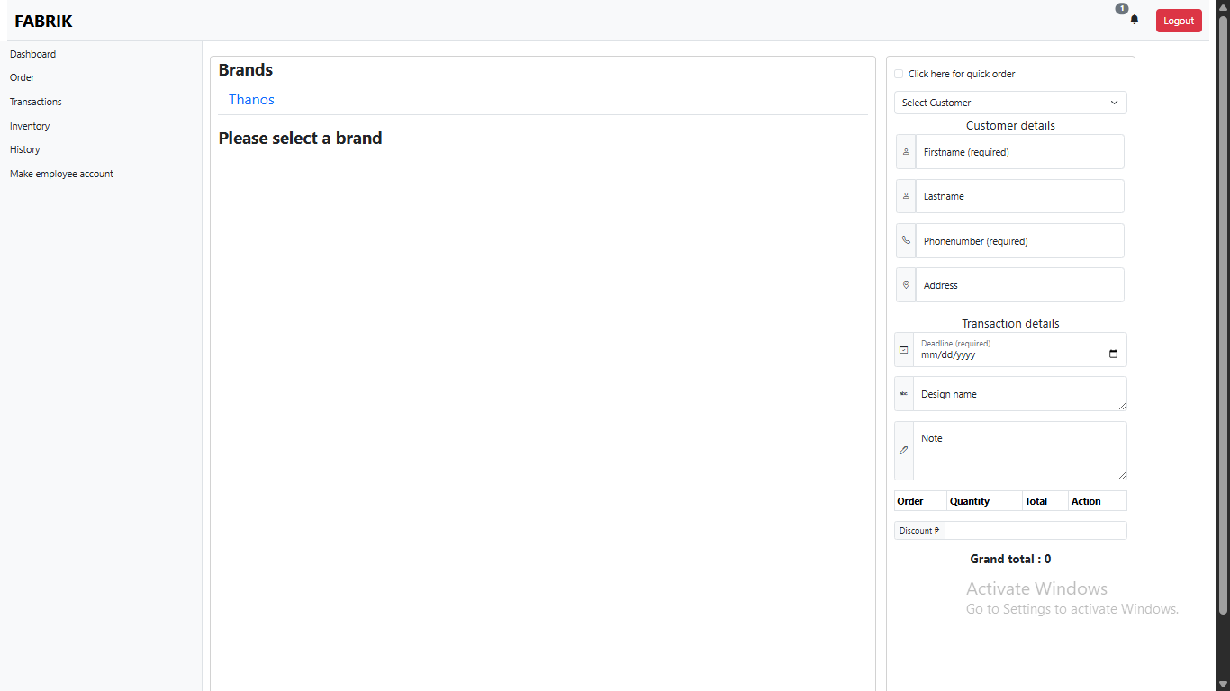

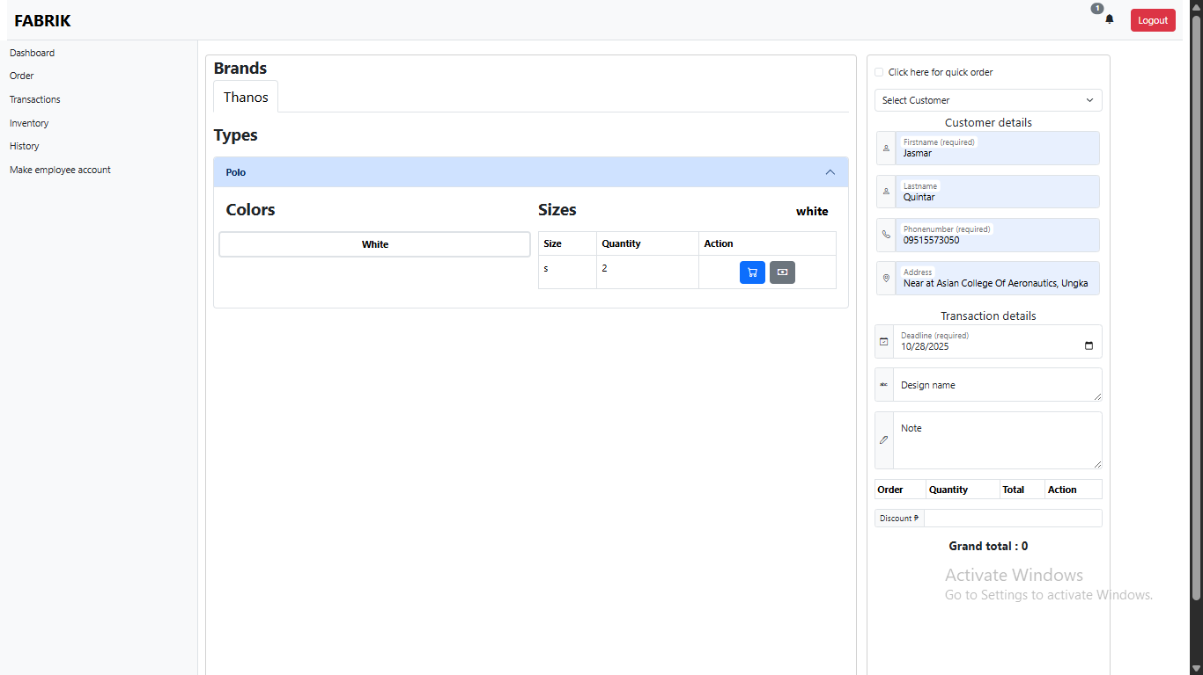

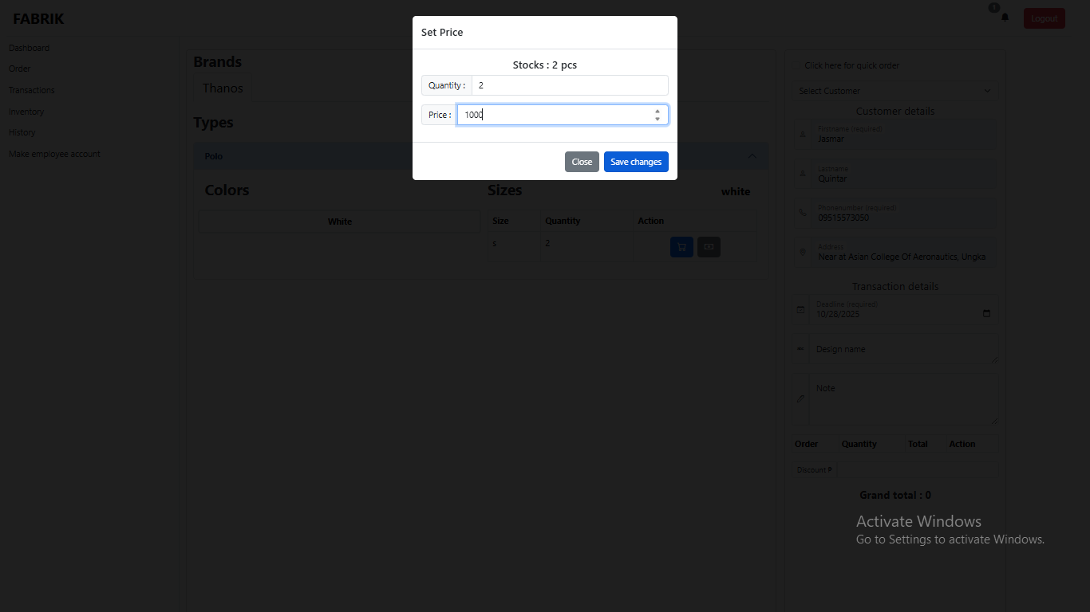

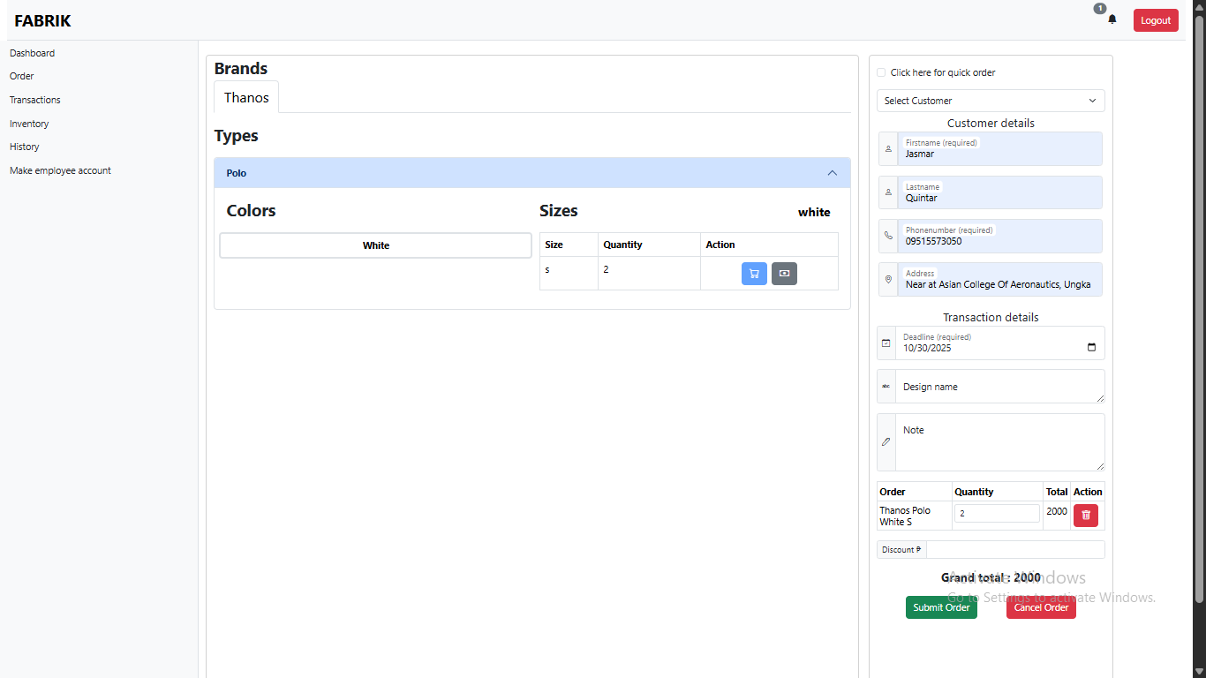

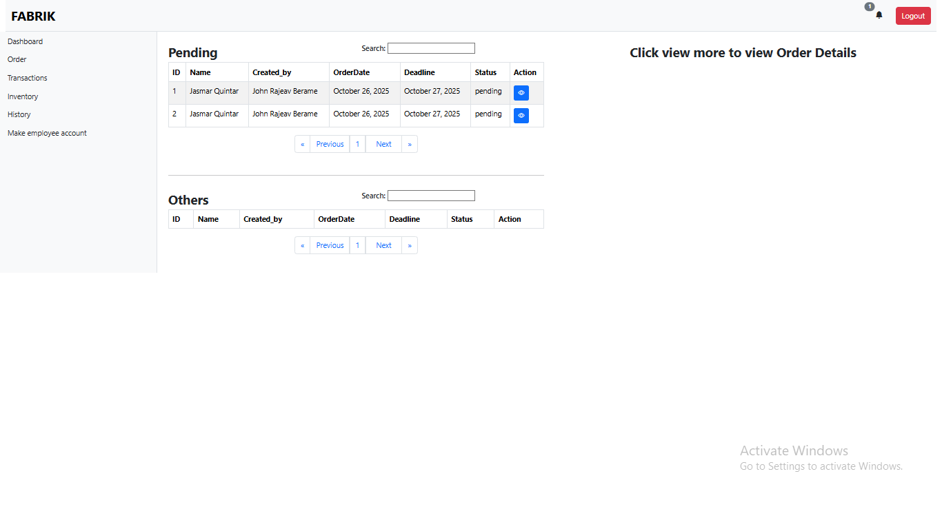
Transactions Management Page

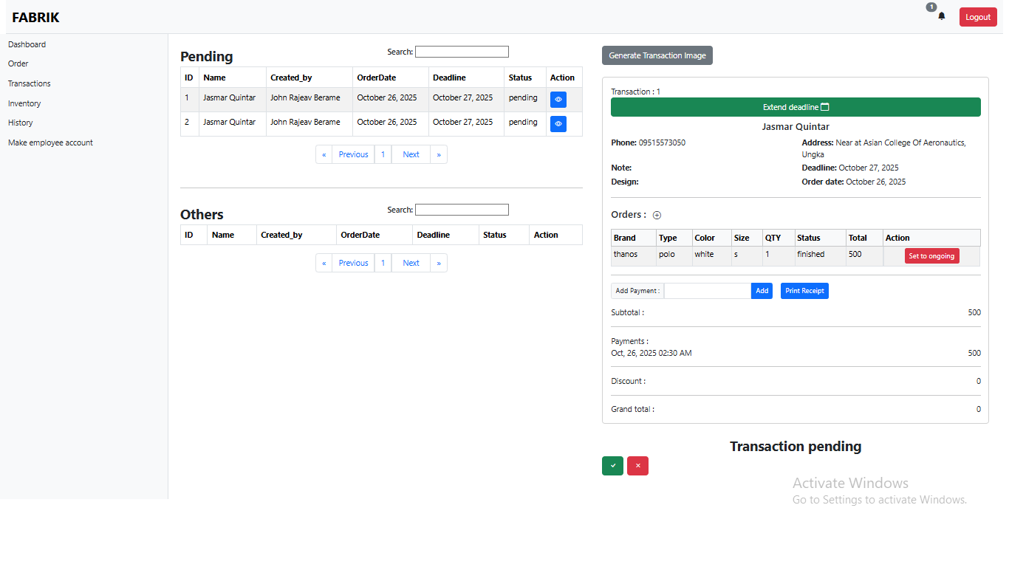

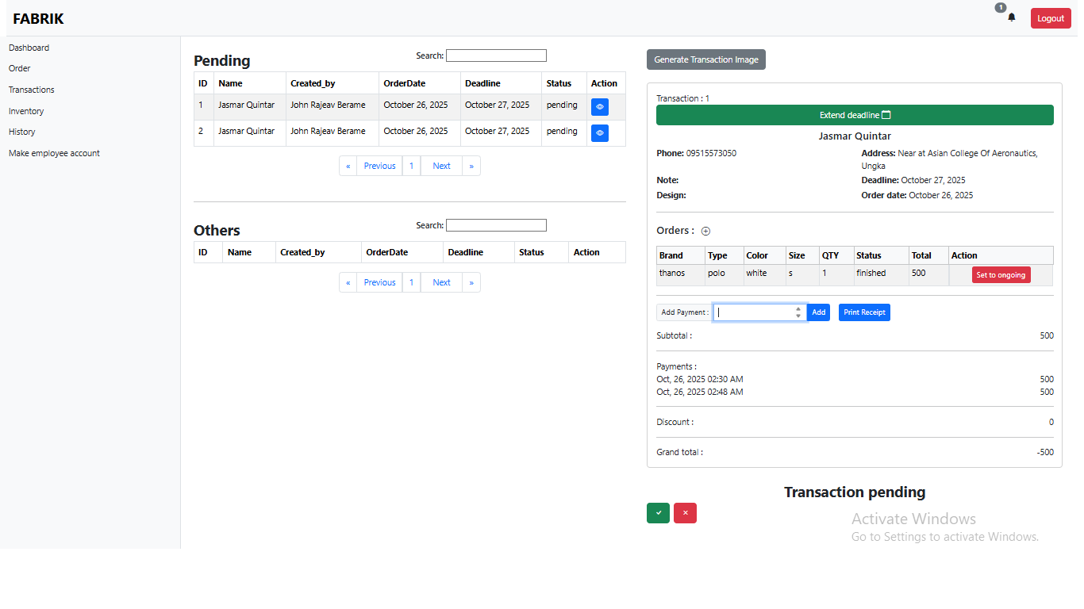

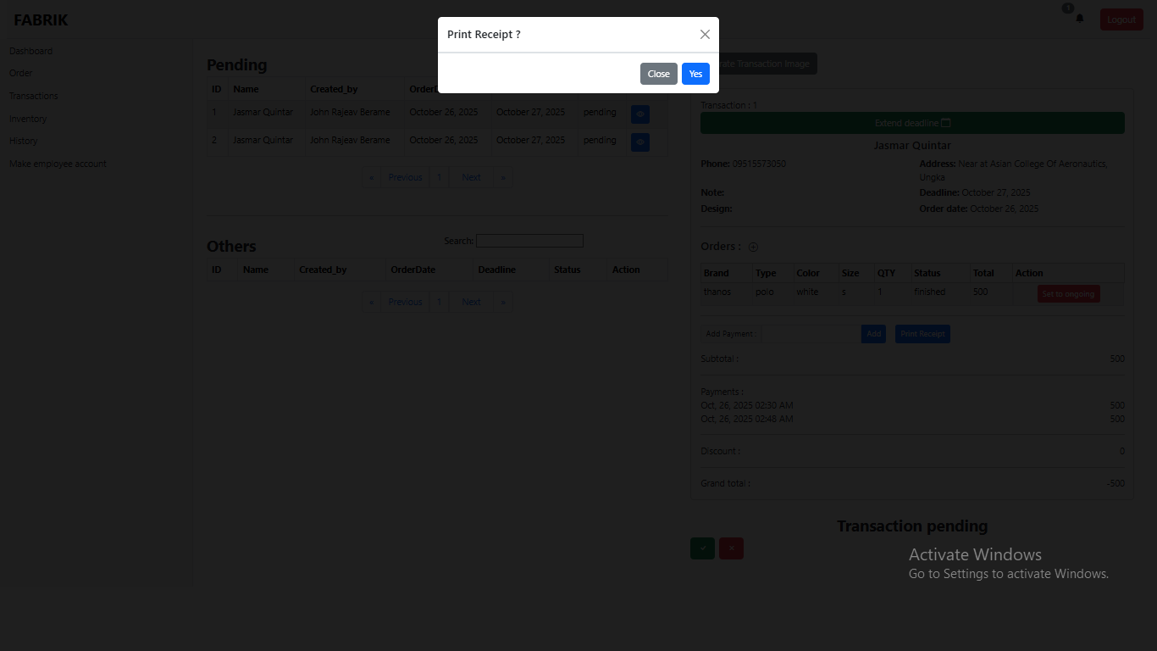

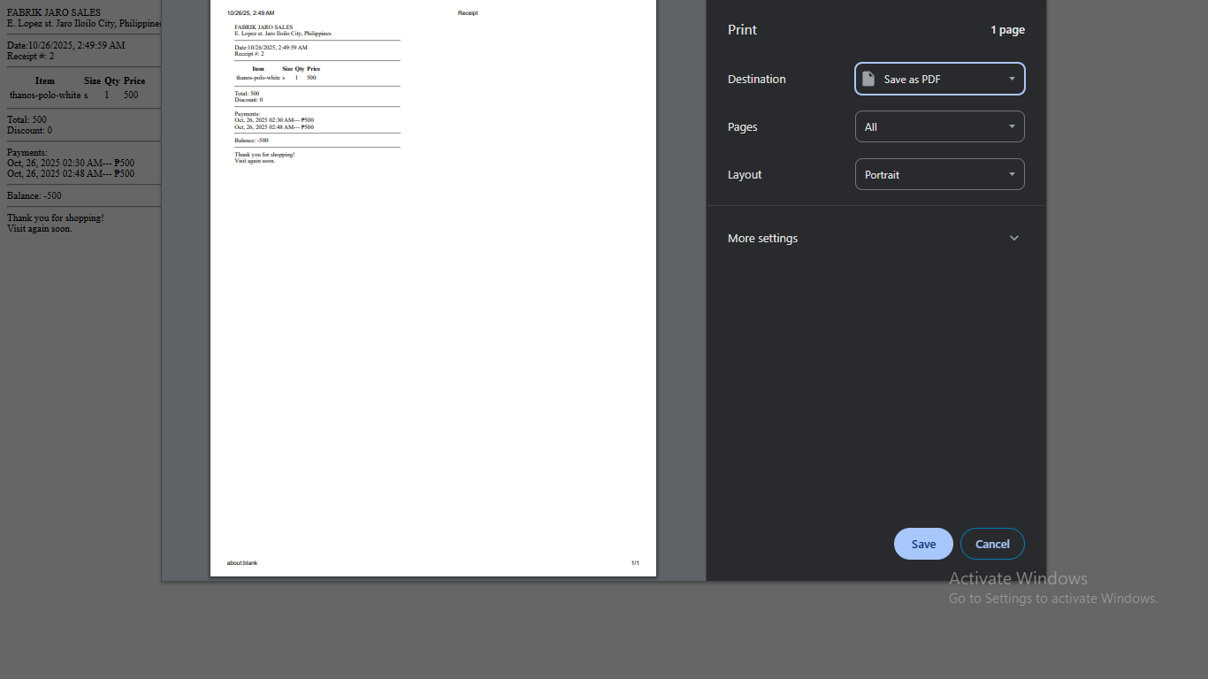

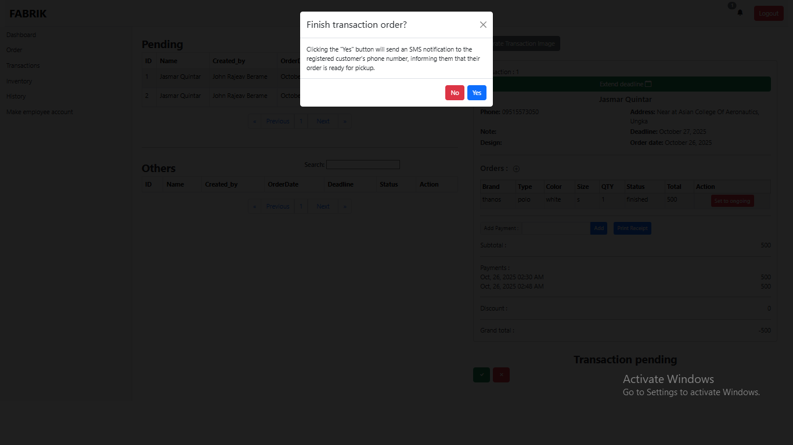

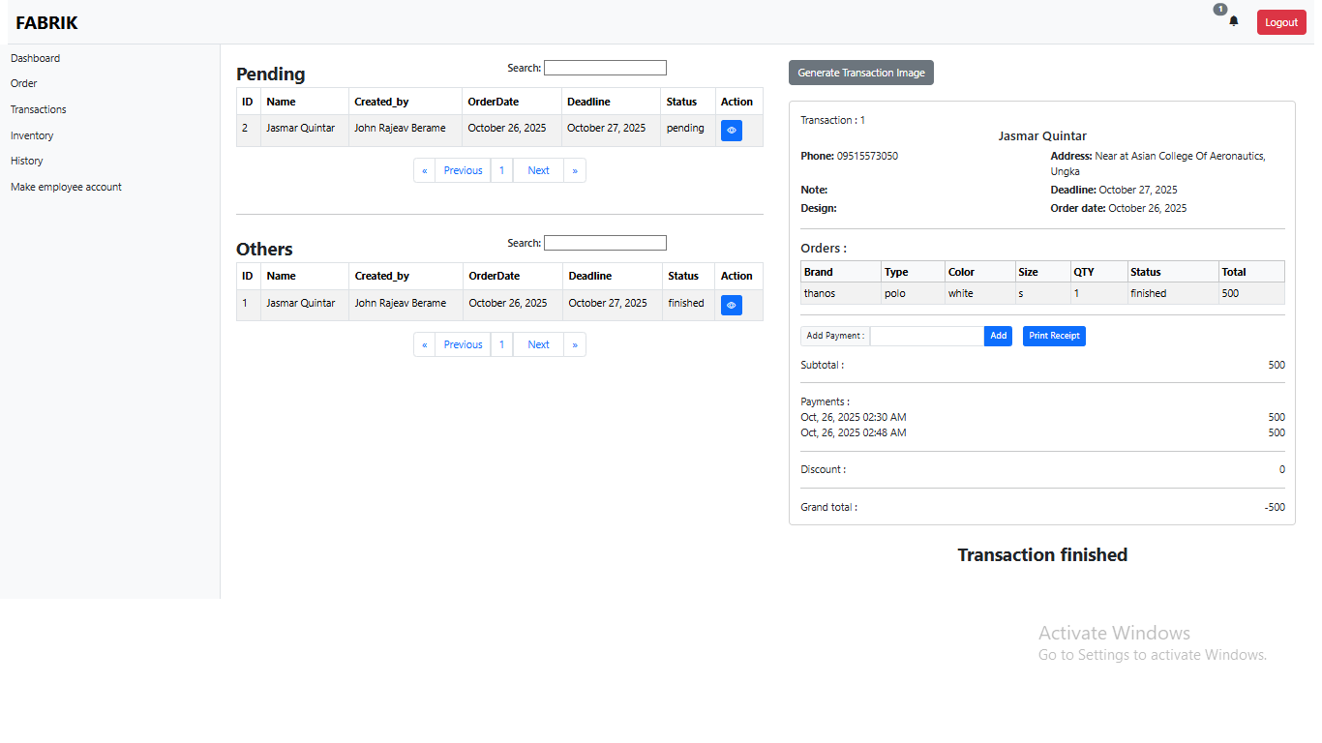

Inventory Management Page
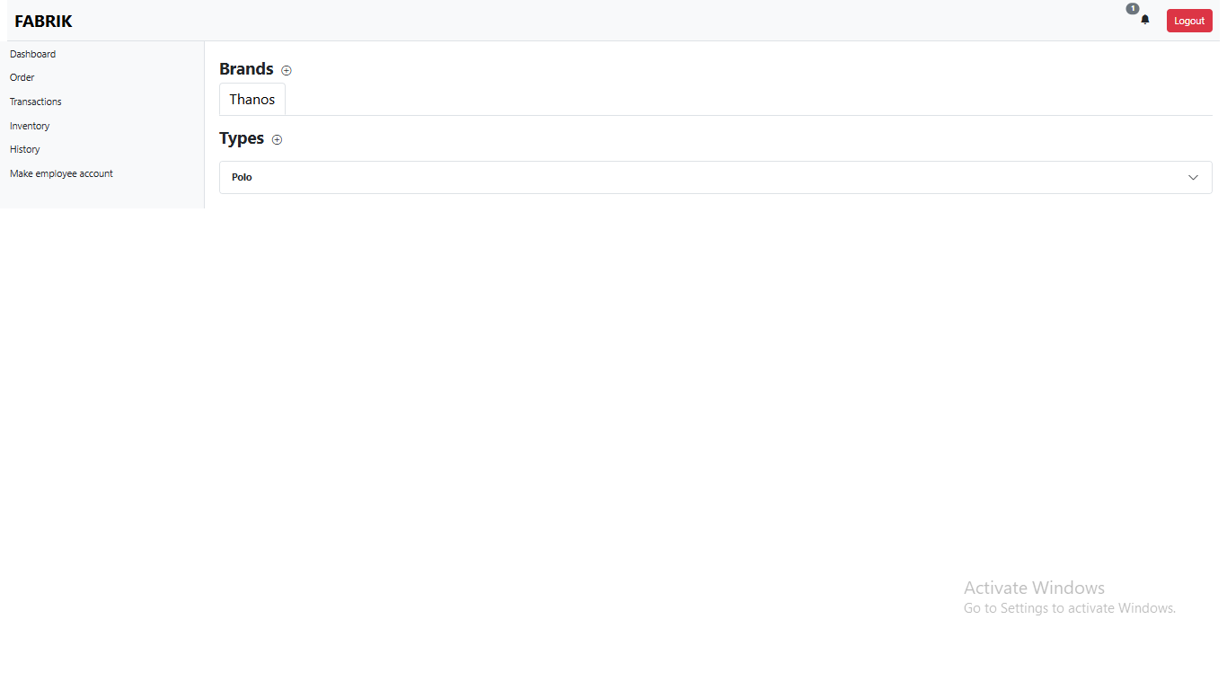

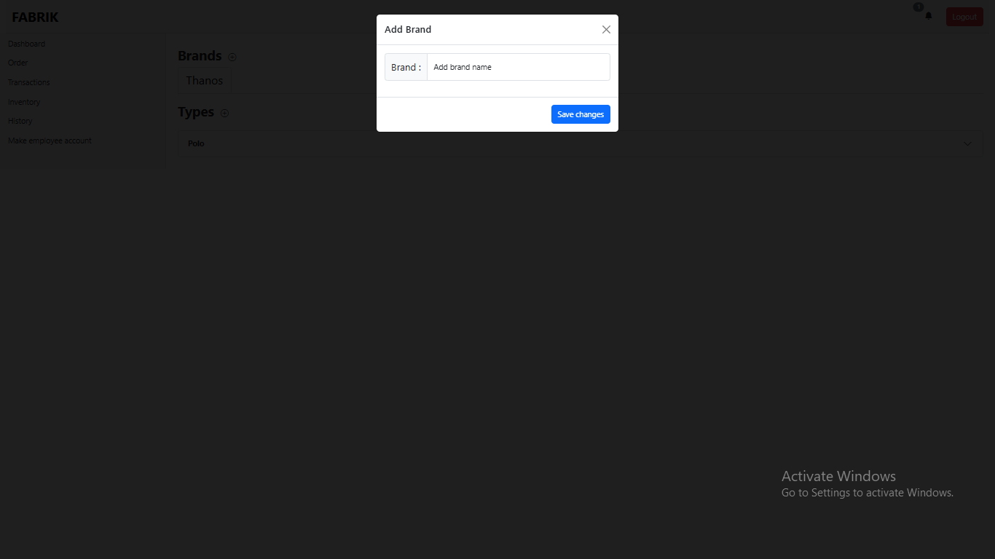

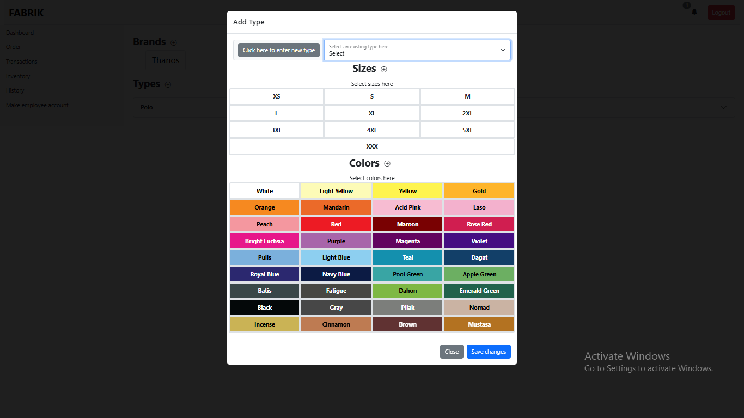

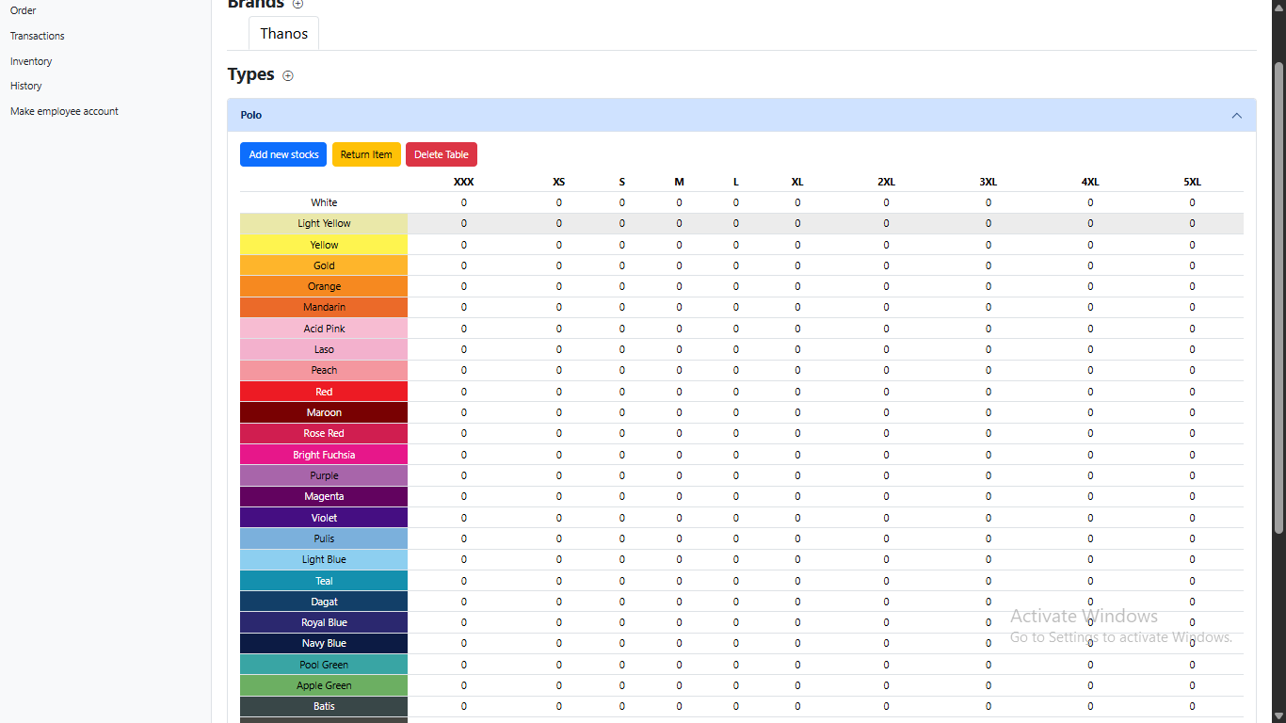

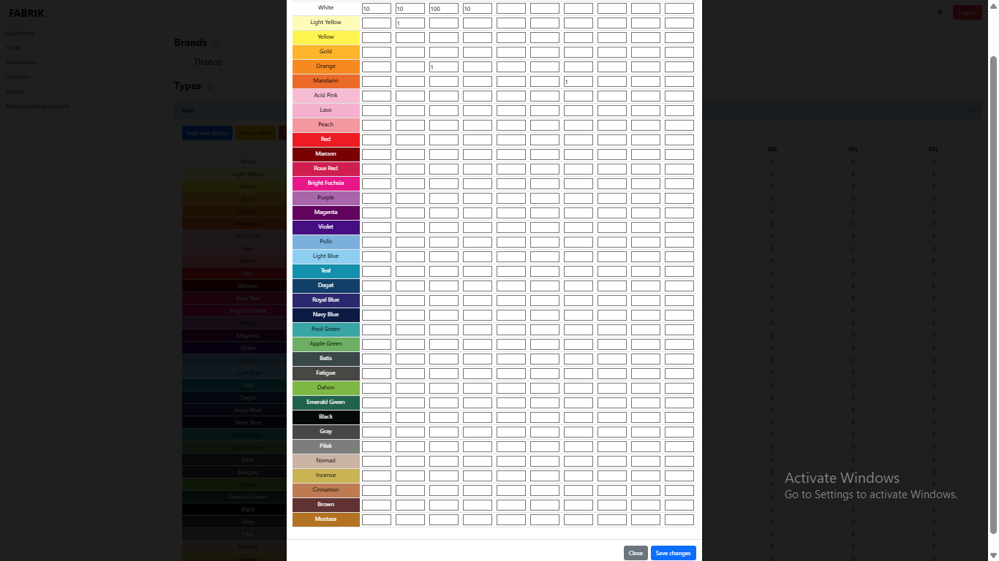

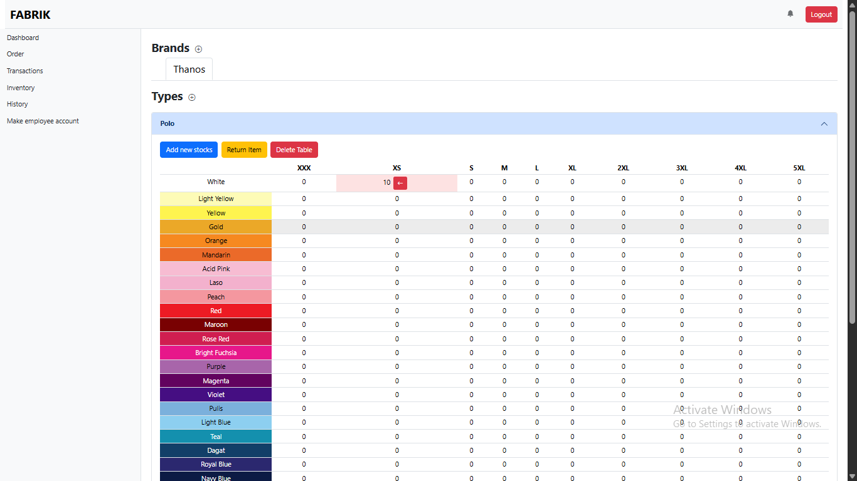

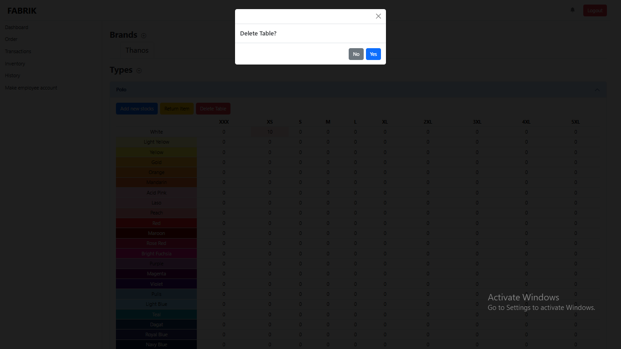

History Page
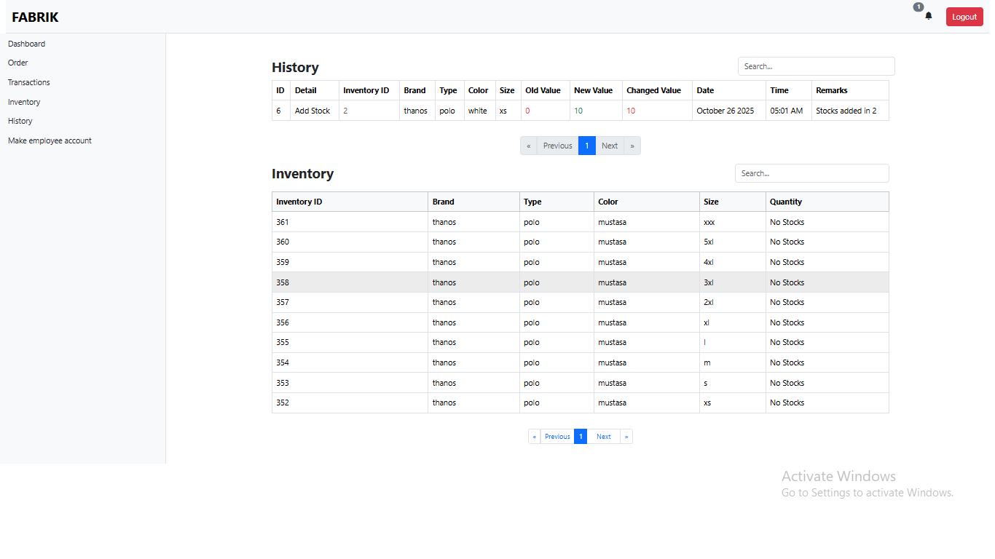

Make Employee Account
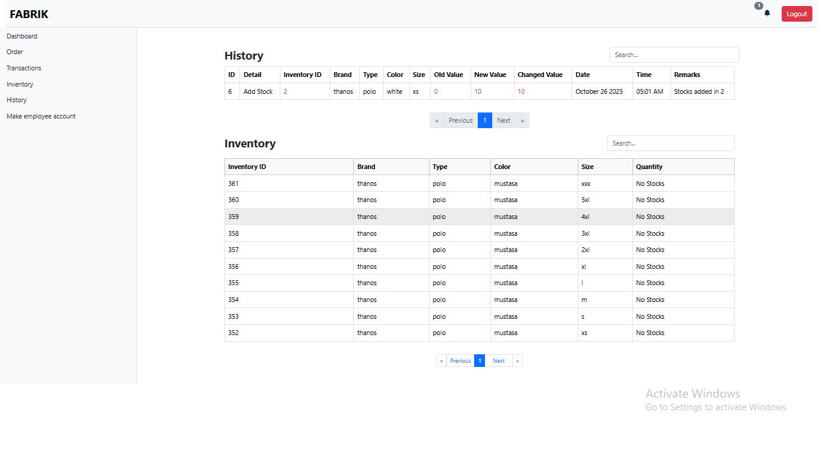

System Features and Functionalities
The FABRIK Workflow Order and Inventory Management System (OIMS) was developed to streamline business operations through automation, real-time tracking, and data integration.
Below are the major features and functionalities that define the system’s overall performance and usability.

1. User Authentication and Role Management
- Secure login system that authenticates user credentials.
- Separate access levels for Administrators and Staff, ensuring data privacy and controlled system access.
- Administrators can manage user accounts, while staff focus on daily operational tasks.

2. Order Management
- Allows staff to record and update customer orders efficiently.
- Automatically calculates total costs based on quantity and product price.
- Generates digital or printable receipts for every confirmed transaction.
- Automatically updates the order history and integrates it with the reporting module.

3. Inventory Management
- Tracks real-time stock levels and updates inventory automatically after each transaction.
- Generates low-stock alerts to prevent shortages.
- Enables administrators to add, edit, or delete product information.
- Supports organized categorization of items for easy management.
4. Dynamic Reporting and History Module
- Produces comprehensive sales and inventory reports for any given date range.
- Displays transaction summaries, customer activity, and stock movements.
- Provides exportable reports for documentation and analysis.
- Helps management make data-driven business decisions.

5. Automated SMS Notification
- Sends real-time text notifications to customers regarding their order status (confirmation, processing, or delivery).
- Improves communication and customer satisfaction.
- Uses an integrated API service for fast and reliable SMS delivery.

6. Receipt Generation
- Automatically generates official receipts after each successful transaction.
- Includes order details such as item names, quantities, prices, totals, and timestamps.
- Can be saved or printed for record-keeping and customer reference.

7. Dashboard Overview
- Provides a centralized view of key business metrics, including total sales, available stock, and recent orders.
- Displays alerts and reminders for pending transactions or low inventory.
- Designed with an intuitive interface for quick access to core modules.

System Repository and Project Structure
This section presents the technical structure and organization of the FabrikFlow: POS and Inventory Management System project. It provides an overview of the system’s repository, folder arrangement, and core development components.
1. System Repository
The source code and related project files are stored in a centralized repository to ensure easy collaboration, version tracking, and backup. It includes the main application code, database files, and API integrations. All assets and configurations are organized for maintainability and scalability.

Repository URL: https://github.com/rajaev21

Project Structure
The overall structure of the OIMS project follows a clear modular organization to separate front-end, back-end, and database components.

FabrikFlow-System/
├── src/
│ ├── frontend/
│ │ ├── pages/
│ │ │ ├── login.html

│ │ │ ├── dashboard.html
│ │ │ ├── inventory.html
│ │ │ ├── orders.html
│ │ │ ├── reports.html
│ │ │ └── sms_notifications.html
│ │ ├── css/
│ │ │ └── styles.css
│ │ ├── js/
│ │ │ ├── auth.js
│ │ │ ├── inventory.js
│ │ │ ├── orders.js
│ │ │ └── reports.js
│ │ └── assets/
│ │ └── images/
│ │ └── logo.png
│
│ ├── backend/
│ │ ├── controllers/
│ │ │ ├── AuthController.php
│ │ │ ├── InventoryController.php
│ │ │ ├── OrderController.php
│ │ │ ├── ReportController.php
│ │ │ └── SMSController.php
│ │ ├── models/
│ │ │ ├── User.php
│ │ │ ├── Inventory.php
│ │ │ ├── Order.php
│ │ │ └── Report.php
│ │ ├── config/
│ │ │ ├── database.php

│ │ │ └── sms_config.php
│ │ └── api/
│ │ ├── send_sms.php
│ │ └── generate_receipt.php
│
│ └── database/
│ ├── fabrikflow.sql
│ └── migrations/
│ ├── create_users_table.sql
│ ├── create_inventory_table.sql
│ ├── create_orders_table.sql
│ └── create_notifications_table.sql
│
├── documentation/
│ ├── user_manual.pdf
│ ├── developer_guide.pdf
│ └── system_architecture.png
│
└── deployment/
├── hosting_instructions.txt
└── system_build.zip

Category | Technology
Programming Languages | PHP, JavaScript
Database | MySQL
Frontend | HTML, CSS, Bootstrap
Development Tools | XAMPP / Visual Studio Code
SMS API Integration | Textbee.dev
Version Control | Git / GitHub

Table 5. Technologies used

Chapter 5

Summary
This study aimed to design and develop the FabrikFlow POS and Inventory Management System with SMS Notifications for Custom T-Shirt Printing (OIMS) to enhance the efficiency and accuracy of managing orders and inventory operations. The system was created to automate manual processes, reduce human error, and provide real-time access to transaction data. It integrates modules for order processing, inventory tracking, report generation, receipt creation, and SMS notifications, ensuring a seamless workflow for both administrators and staff.
The development followed a systematic process that included requirement analysis, system design, coding, testing, and evaluation. Each phase was carried out to ensure that the system met the needs of FABRIK’s daily operations and addressed the challenges found in manual recordkeeping and outdated processes.
Results from the testing and implementation revealed significant improvements in transaction speed, inventory accuracy, and user satisfaction. The system successfully achieved its objectives by providing an automated, easy-to-use, and efficient platform for managing both orders and inventory, proving its effectiveness as a reliable business solution for small-scale enterprises like FABRIK.

Conclusion
Based on the findings of the study, the FabrikFlow POS and Inventory Management System with SMS Notifications for Custom T-Shirt Printing proved to be an effective and reliable solution for automating the company’s point-of-sale and inventory operations. It successfully reduced manual workload, minimized data errors, and improved the speed and accuracy of transaction processing.
By integrating key features such as Order Management, Inventory Monitoring, Sales Reporting, Receipt Generation, and SMS Notifications, the system streamlined business workflows and strengthened coordination between staff and administrators. This automation led to more efficient tracking of customer orders, faster updates of stock records, and improved communication with clients through real-time notifications.
User evaluations showed that the system is easy to use, accurate, and dependable, providing a modernized approach to managing daily operations in a custom T-shirt printing business. Overall, the FabrikFlow System fulfilled its intended objectives by enhancing operational efficiency, promoting data accuracy, and demonstrating how tailored software solutions can drive productivity and digital transformation in small-scale enterprises.

Recommendations
Based on the development process, testing results, and user evaluation of the FabrikFlow POS and Inventory Management System with SMS Notifications for Custom T-Shirt Printing, the following recommendations are proposed to enhance the system’s functionality and future performance:
- System Expansion
Future versions of the system may include advanced features such as multi-branch inventory tracking, supplier management, and sales forecasting. These additions would improve scalability and enable broader business integration.
- Mobile Application Development
A mobile version of the system is recommended to allow staff and administrators to manage orders, inventory, and notifications conveniently from smartphones or tablets, promoting flexibility and accessibility.
- Cloud Storage and Backup
Integrating cloud-based storage will strengthen data security and allow automatic backups of transactions and inventory records. This will ensure data availability even in the event of hardware failure or system downtime.
- User Training and Support Materials
Conducting short training sessions or providing user manuals and tutorials can help new users adapt to the system faster, ensuring efficient operation and minimizing errors during actual use.

- Scalability and Performance Testing
Additional testing in larger business environments such as warehouses or multi-branch retail stores is advised to assess the system’s performance, scalability, and responsiveness under high transaction volumes.

References (APA Format)
Efraim Turban,Jae Lee, David King, H. Michael Chung(2000). Electronic Commerce A Managerial Perspective: Prentice Hall.

Appendices

Appendix A: System Interface Screenshots
Below are the primary interfaces of the FabrikFlow POS and Inventory Management System with SMS Notifications for Custom T-Shirt Printing:
- Login Page – Allows both admin and staff users to securely access the system.
- Dashboard – Displays real-time summaries of total orders, available stocks, and system notifications.
- Order Management Module – Used to record and process new customer orders, update statuses, and track progress.
- Inventory Management Module – Handles product listing, stock adjustments, and low-stock alerts.
- Report Generation Page – Produces daily, weekly, or monthly sales and inventory reports.
- SMS Notification Interface – Automatically sends text message updates to customers about order status.

Appendix B: Use Case Diagram
The Use Case Diagram illustrates the interactions between system actors and processes.
Actors:
Administrator
- Has full control over all modules.

- Manages user accounts, inventory, orders, and generates reports.
- Receives SMS notifications for system alerts or critical events.
Staff
- Handles daily operations such as creating and updating orders.
- Updates inventory quantities, generates receipts, and views reports.
- Interacts directly with customers through order processing.
System (Internal Automation)
- Automatically generates receipts, sends SMS notifications, and records reports or logs.
- Ensures all transactions are validated and stored securely in the database.
Use Cases:
- Login
- Manage Orders
- Manage Inventory
- Generate Reports
- Send SMS Notifications
- Logout

Appendix C: Data Flow Diagram (DFD)

The following Data Flow Diagrams illustrate how information moves through the FabrikFlow: POS and Inventory Management System ).
They show the interaction between external entities, internal processes, and data stores that support order tracking, inventory control, reporting, and SMS notification functions.

Figure 2 — Level 0 Data Flow Diagram (Context Diagram)
Overview of FabrikFlow POS and Inventory Management System
The Level 0 DFD provides a context-level overview of the entire system. It shows how data flows between the external entities (Customer, Employee, and Administrator) and the central system (OIMS).
Main Data Flows:
- Customer → System: Sends order details, design requests, and payment information.
- System → Customer: Sends order confirmation, production updates, and SMS notifications.
- Employee ↔ System: Inputs and updates order data, manages inventory, and retrieves transaction reports.
- Administrator ↔ System: Monitors overall activity, manages users, and generates analytics or sales reports.

Core Data Store:
- Database / Central Repository — stores orders, products, inventory records, user accounts, and reports.
Figure 3 — Level 1 Data Flow Diagram
Detailed Data Flow of FabrikFlow POS and Inventory Management

The Level 1 DFD decomposes the main system into its key functional processes and demonstrates how data moves between them and the related data stores.
Primary Processes:
- Login and Authentication (1.0)
- Verifies user credentials and role access (Admin / Staff).
- Data Store: User Accounts.
- Order Processing (2.0)
- Records new customer orders, calculates totals, and generates receipts.
- Data Stores: Orders, Transactions, Receipts.
- Inventory Management (3.0)
- Updates stock levels automatically after each confirmed order.
- Data Store: Inventory Records.
- Pricing and Product Configuration (4.0)
- Adjusts product prices based on quantity, size, and print complexity.
- Data Store: Product Details / Pricing Table.

- SMS Notification (5.0)
- Sends automated status updates (confirmation, in-process, delivery).
- Uses integrated SMS API service.
- Report and History Generation (6.0)
- Compiles daily/monthly sales, order trends, and inventory movement for management.
- Data Stores: Reports, History Logs.
Appendix D: User Evaluation Summary
FabrikFlow: POS and Inventory Management System was conducted through direct user testing, observation, and informal feedback sessions with the staff and administrator of FABRIK.
This approach allowed the researchers to gather practical and experience-based responses regarding the system’s functionality, usability, and overall performance.

Appendix E: Summary of User Feedback
During the testing phase, both the administrator and staff used the system to perform daily tasks such as order entry, inventory updates, and report generation.
Their comments and reactions were recorded informally during the demonstration.

Evaluation Aspect | User Feedback / Observation
Ease of Use | The system was easy to navigate, with clear buttons and instructions.
Order Processing | Order creation and tracking became faster and more accurate.
Inventory Management | Automatic stock deduction minimized errors and improved accuracy.
Report Generation | Reports were generated instantly, providing helpful summaries.
SMS Notification | Users appreciated the instant updates sent to customers.
Overall Satisfaction | Users found the system efficient, reliable, and time-saving.

Table 6.User feedback

APPENDIX E: Sample Cover Page

PHINMA UNIVERSITY OF ILOILO
College of Information Technology Education

FABRIKFLOW: POS AND INVENTORY MANAGEMENT SYSTEM WITH SMS NOTIFICATIONS FOR CUSTOM T-SHIRT PRINTING

A Capstone Project
Presented to the Faculty of the
College of Information Technology Education
PHINMA University of Iloilo

In Partial Fulfillment
of the Requirements for the Degree
Bachelor of Science in Information Technology

By: Berame, John Rajeav J.
Quintar, Jasmar I.

Date: June 2024–2025


Appendix F:Grammarian CV

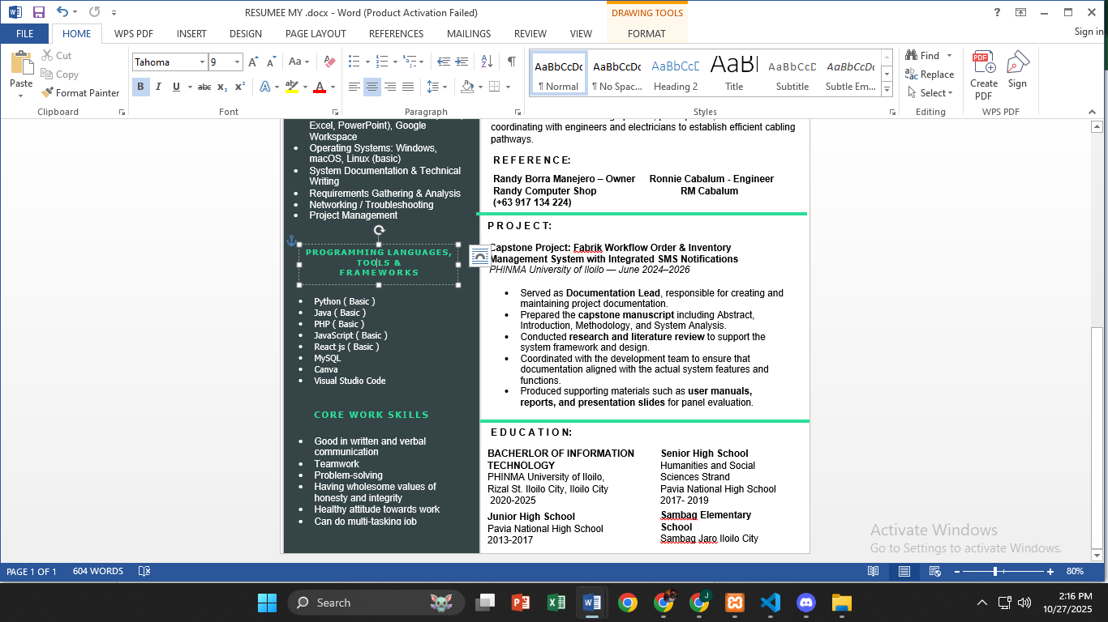

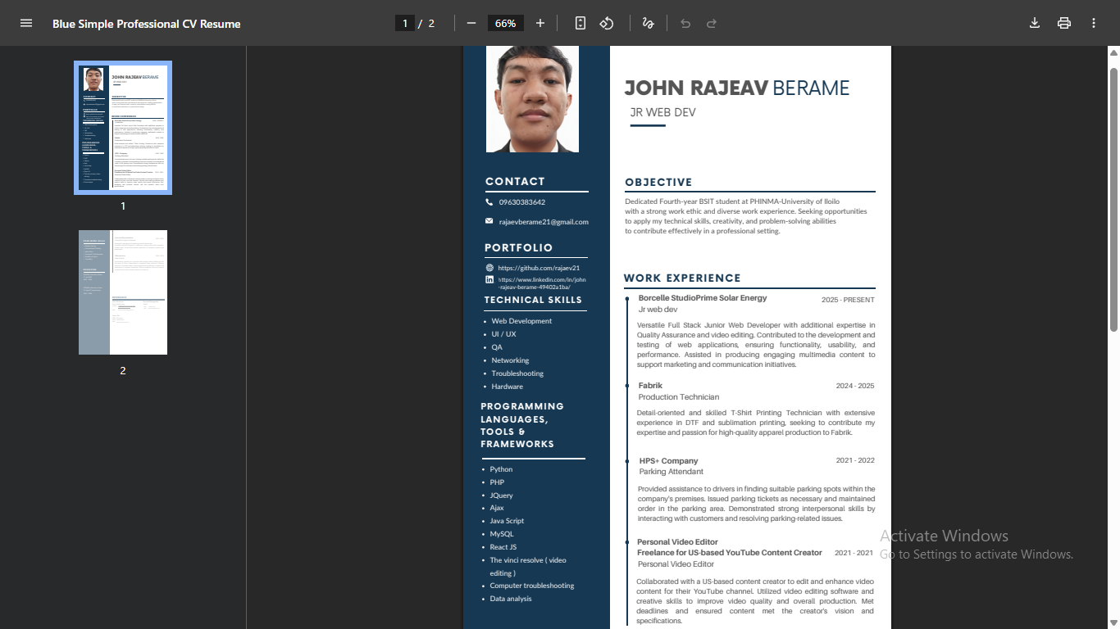

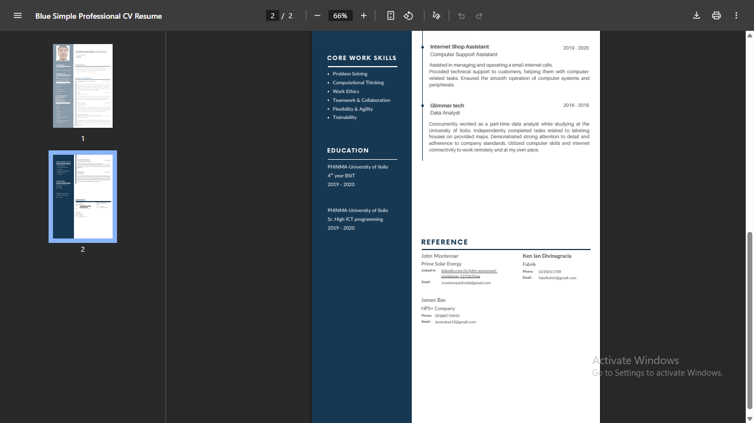

Client Partner
Team Aray ko,
Ungka Jaro Zone 3,
Iloilo City, 5000
jasmarquintar848@gmail.com
09515573059,
October 28, 2025
KEN DIVINAGRACIA,
FABRIK OWNER,
Corner E Lopez Street,
Brgy San Vicente Street,
Jaro, Iloilo City,
5000 Iloilo
Dear Sir/Madam,
Proposal for Memorandum of Agreement for the Use of the FABRIKFlow POS and Inventory Management System
We are pleased to present our proposal for the FABRIKFlow POS and Inventory Management System with SMS Notifications, a comprehensive solution designed to enhance and streamline the operations of FABRIK Custom T-Shirt Printing. This system integrates automation, real-time inventory tracking, and efficient order management to ensure accuracy, transparency, and faster business processes.
To formalize the use and implementation of this system within your organization, we propose the signing of a Memorandum of Agreement (MOA) that clearly outlines the roles, responsibilities, terms, and conditions of both parties. The MOA will also specify details such as project scope, deployment

timeline, data security, and provisions for technical support and system maintenance.
The FABRIKFlow System provides the following benefits:
- Improved accuracy in order and inventory tracking
- Faster processing of customer transactions
- Real-time monitoring and reporting of sales and stock data
- User-friendly interface designed for both staff and administrators
Our team is committed to providing full technical assistance, including system installation, user training, and post-implementation support to ensure a successful integration into your daily operations.
We look forward to discussing this proposal further and collaborating with your organization to optimize your workflow and inventory management process. Please let us know a convenient time for a meeting or if you require any additional information.
Thank you for your time and consideration.

Sincerely,
Jasmar I, Quintar
Team Leader/Documentor
Team Aray ko

MEMORANDUM OF AGREEMENT (MOA)
Between
FABRIK Custom T-Shirt Printing
And
Jasmar I, Quintar, John Rajeav J, Berame

Purpose: This Memorandum of Agreement is entered into by and between FABRIK Custom T-Shirt Printing, located at Corner E. Lopez Street, Brgy. San Vicente, Jaro, Iloilo City, and Team Aray Ko, represented by Jasmar I. Quintar, for the purpose of implementing the FABRIKFlow POS and Inventory Management System with SMS Notifications. The agreement ensures collaboration in deploying, maintaining, and using the system to improve inventory and order management.
Scope of Agreement:
- Responsibilities of FABRIK Custom T-Shirt Printing:
- Provide access to relevant operational data required for system deployment and testing.
- Cooperate with Team Aray Ko for timely implementation, training, and system usage.
- Ensure proper internal coordination for smooth integration of the system into daily operations.

Responsibilities of Team Aray Ko:
- Deploy and configure the FABRIKFlow POS and Inventory Management System.
- Provide full technical support, including installation, user training, and post-implementation assistance.
- Ensure proper documentation, system updates, and guidance for staff to use the system effectively.
- General Provisions:
- The MOA covers project deployment, data security, and system maintenance responsibilities.
- Both parties agree to cooperate in good faith to ensure the success of the project.
- Any issues arising during the implementation shall be resolved collaboratively.

Signatures:
For FABRIK Custom T-Shirt Printing:
Ken Divinagracia
Owner
Date: _______________
For Team Aray Ko:
Jasmar I. Quintar, and
John Rajeave J, Berame
Date: _______________

